Student Handbook -2020

DEPARTMENT OF CHEMICAL & PROCESS ENGINEERING
UNIVERSITY OF MORATUWA
SRI LANKA

CONTENT
CONTENT 1
THE DEPARTMENT OF CHEMICAL & PROCESS ENGINEERING 1
‘DEAR STUDENTS, WELCOME TO THE CPE FAMILY…’ 4
WHAT IS CHEMICAL AND PROCESS ENGINEERING? 5
WHY STUDY CHEMICAL AND PROCESS ENGINEERING? 6
CAREER OPPORTUNITIES FOR CHEMICAL AND PROCESS ENGINEERING GRADUATES 7
TESTIMONIALS 8
THE JOURNEY OF DCPE 12
ACADEMIC STAFF MEMBERS 15
NON-ACADEMIC STAFF MEMBERS 19
UNDERGRADUATE DEGREE PROGRAM 22
Graduate Program Outcomes Profile 22
Program Educational Objectives 23
Graduation Credit Requirement 24
Normal Minimum Credit Requirement 24
Semester Coordinators 24
Teaching and Learning 25
Curriculum 28
Requirements for Focus Area 33
Requirements for Entrepreneurship Minor 34
Modules Offered to Other Fields of Specialization 34
Modules 35
Semester II 35
Semester III 38
Semester IV 43
Semester V 47
Industrial Training 51
Semester VI 52
Semester VII 56
Semester VIII 65
Research 77
Comprehensive Design Project 79
Industrial Training 80
Awards Available for DCPE Students 82
INDUSTRY COLLABORATION 83
SPECIAL EVENTS AND PROGRAM 85
SOCIETIES 87
LABORATORY FACILITIES AND RESOURCES 89
OTHER INFORMATION 96
FLOOR PLAN OF DCPE 98

THE DEPARTMENT OF CHEMICAL & PROCESS ENGINEERING
Mission
The Department of Chemical and Process Engineering will strive to educate, conduct research and offer consulting services with dedication, devotion and commitment and aim to be a place of excellence through internationally recognize programs for the benefit of the society
Vision
Delivering Chemical and Process Engineering knowledge, skills and innovation for a sustainable tomorrow

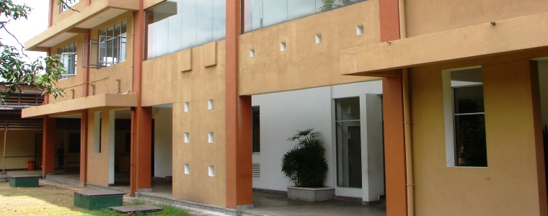
The Department of Chemical and Process Engineering at University of Moratuwa is one of the premier engineering departments in the country. Being operated with a vision to standardize, optimize and scale up the production processes in a commercially viable manner through sustainable utilization of raw materials, the department has its unique mission to satisfy its objectives.
The department offers the honours degree in Bachelor of Science of Engineering in the field of Chemical and Process Engineering for the undergraduates in fields of focus areas in Environmental and Energy Engineering, Food and Biochemical Engineering, Polymer Engineering, and Petroleum Engineering while it also offers programs for the postgraduates. The M.Sc./ PG Dip. in Polymer Technology and M.Sc./ PG Dip. in Sustainable Process Development are two taught Master’s programs available at the department and it also conducts Research programs leading to M.Sc., M.Phil., and Ph.D. degrees.
The competency and friendliness of academic and academic support staff members, the stimulating atmosphere of the department with well-equipped laboratory facilities and many valuable resources provided for the students, offer the students with a better learning environment to equip students with necessary knowledge and skills required for Chemical and Process Engineering graduates.
Being established in 1972 only with 8 undergraduates, the department proudly demonstrates much evidence for its immense growth during its journey through the years. The number of undergraduate student intake has been increased up to 80 students per batch, and at present, the student body of the Department of Chemical and Process Engineering is consisted with over 300 undergraduates studying at various levels of their bachelor’s degree program, Masters students, M.Phil. students and Ph.D. students.
Research, being an integral part of the curriculum of undergraduate and postgraduate studies, not only boosts the research potential of the students but also benefits the field of Chemical and Process Engineering through the flow of huge contribution of better solutions and innovative ideas into it. The availability of well-functioning laboratory facilities with the well-guided supervision enhances the value of the research activities.
The collaboration of the Department of Chemical and Process Engineering with the industry is also huge. The industry facilitates the department with internship opportunities for the undergraduates, with competent and well-experienced mentors for the mentoring programs that are being conducted by the department, and to organize field visits for the students in order to enhance the competencies of the undergraduates. The close relationship with the industry facilitates the prospective fresh graduates from the department to find career opportunities with ease. The Department Industry Consultancy Board strengthens the bond between the department and industry while improving the value of the degree program to mold the proficiency of the future-graduates to fulfill the industrial requirements.
The strong affiliation between the department and industry is beneficial for the industry too. The department offers consultancy services for the industry through various industrial projects and researches to grant the industry with many valuable innovations and better solutions for the sustainable development of the industry and the country.
The DSI incubator provides proof for the strong bond between the department and the industry. The industry and academic institutes also provide the prospective students of Department of Chemical and Process Engineering with many academic awards and scholarship positions in recognition for their competencies.
The department not only encourages and promotes the students to associate with professional institutes and various societies and associations but also it encourages and facilitates many extra-curricular activities and sports activities, in order to enhance their knowledge and soft-skills as a prospective professional.
The time at the department under the wings of well-qualified and well-experienced academic staff, in a well-established and well-maintained stimulating environment is definitely a career developing and an exciting experience that every student should encompass.
The Department of Chemical and Process Engineering at University of Moratuwa is a blessing to every aspect as it always strives to deliver chemical and process engineering knowledge, skills and innovation for a sustainable tomorrow through education, research and consultancy services with dedication, devotion and commitment.

Contact Information
Department Office
Website : http://www.cpe.mrt.ac.lk
E-mail : cpe@uom.lk
Phone (General) : +94 112 640 051 Ext. 4100
Direct : +94 112 650 281
Fax : +94 112 650 622
Head of the Department Prof. Shantha Walpalage
E-mail : head-cpe@uom.lk
Phone (General) : +94 112 640 051 Ext. 4101/4106
Direct : +94 112 650 281

Online presence
LinkedIn | :University of Moratuwa - Department of Chemical & Process Engineering  :Chemical and Process Engineering Student Society University of Moratuwa
Facebook | :Department of Chemical & Process Engineering, University of Moratuwa
YouTube | :Department of Chemical and Process Engineering UOM

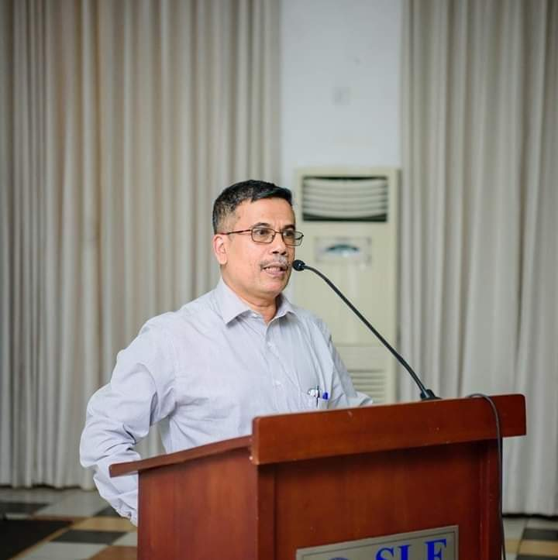
‘DEAR STUDENTS, WELCOME TO THE CPE FAMILY…’

“As the Head of Department, I would like to take this opportunity to thank you for joining the Department of Chemical Process Engineering (DCPE) and welcome you to the Department.”
The Department of Chemical Engineering was first established by gazette notification on 15th February 1972 at Katubadda campus of University of Ceylon with only 8 students. The course was originally termed as Chemical Engineering and Fuel Science and a great support has been received from University of Leeds UK in the development stage of the degree program. In 1998 major revision was done to the degree program and name was changed as Chemical and Process Engineering.
Our main aim is to design processes that transform raw materials into useful and valuable products in a sustainable manner. Chemical and process engineers design/ operate chemical plant for manufacturing petroleum products, chemicals, pharmaceuticals, cement, fertilizers, cosmetics, food beverages, synthetic rubber, plastics, paints, detergents, pulp and paper or any processing products. Additionally, we play a significant role in emerging fields such as biotechnology, biochemical engineering, and nanotechnology.
Department academic staff members are well qualified and consist of 23 full-time members including 1 senior professor, 6 professors and 8 senior lecturers. In addition, the department is supported by strong academic support and technical staff. Current student population in the department is around 400 including the postgraduate students.
Research is an important focus of activity and the Department has faculty who lead high quality research programs in a wide spectrum of areas. Our Department has strong links with industry and is prepared to do collaborative research and development with them. Presently we have one of the oldest incubators for conducting product and process development for DSI Samson industries. Our alumni, around 1000, have rewarding careers in the chemical and process industries, universities and research institutes in local as well as international organizations. Many of our most dedicated alumni made their way into outstanding leadership roles and many continue to support the Department in a variety of ways.
Historically our students have shown the excellence in sports and other extra-curricular activities. Chemical Engineering Student Society is the hub for the student activities in the department and numbers of annual events are organized by the DCPE students.
Finally, I would like to welcome you to the one of the most interesting specialization of Engineering, wishing you all the best for your future endeavors in the Department of Chemical and Process Engineering.
Professor Shantha Walpalage
Head of the Department

WHAT IS CHEMICAL AND PROCESS ENGINEERING?

Chemical and Process Engineering is the profession in which knowledge of Mathematics, Chemistry, Physics, Biology and other Natural Sciences gained by study, experience and practice is applied with judgment to develop economical ways of using materials and energy for the benefit of mankind.
More typically, they turn raw materials into valuable products. The necessary skills encompass all aspects of design, testing, scale-up, operation, control, and optimization. Hence this requires a detailed understanding of the various "unit operations", such as distillation, mixing, evaporation, crystallization, and biological processes that make these conversions possible.
It's true that Chemical Engineers are comfortable with Chemistry, but they do much more with this knowledge than just mix and make chemicals. For each and every Chemical and Process Engineering affairs the knowledge of Mathematics, Physics, Chemistry and Biology are greatly utilizing, and these majors are the foundations for Chemical and Process Engineering upturns.
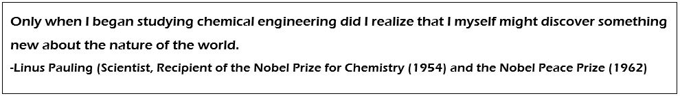
Resting on the above foundations the Chemical and Process Engineering sciences sprout higher and higher utilizing mass, momentum and energy transfers hand along with Thermodynamics and Chemical Kinetics.
It would be correct to say that the term Chemical in Chemical and Process Engineering refers more towards the knowledge and experience in terms of the applied sciences whereas Process Engineering comprises of the designing, operating, maintaining and optimising of the processes that convert raw materials into finished goods.
The breadth of scientific and technical knowledge inherent in this profession has caused world scientists to describe the Chemical and Process Engineer as the "Universal Engineer".

WHY STUDY CHEMICAL AND PROCESS ENGINEERING?
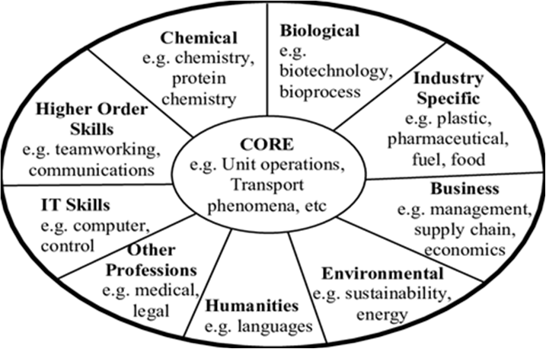
You should consider a Chemical engineering degree if you want,
- A career progression along with a growing global profession
- To make money from your own passion of engineering, technological or management.
- To make a difference not only on your economical, mental and career satisfaction but to satisfy the aspirations and necessities of the society
- A large manifold of occupations with a diverse professional experience in a highly dynamic working environment
- To travel the world to express your lifestyle
- To actively contribute towards solving urgent issues such as the energy crisis and pollution, and work towards achieving sustainability

CAREER OPPORTUNITIES FOR CHEMICAL AND PROCESS ENGINEERING GRADUATES
There are a countless number of industries where Chemical and Process Engineering is used in. As examples petroleum and petrochemical industries, mineral processing, advanced materials, food and beverage processing, pharmaceutical, biotechnological industries, polymer industries, ceramic industries, electronic base industries and much more. Chemical and Process engineering works hold in hands with fellow engineering disciplines such as mechanical, electrical and electronics, civil and material science.
The broad basis of their scientific, engineering, technological and management education upgrade the applications of the Chemical and Process Engineering skills in any other sister fields such as business, supply chain, process analysis, health and safety and etc. which do not seem like a result of chemical and Process Engineering evolution.
Chemical Engineers might expect to work in,
- Chemical, petroleum and petrochemical industries
- Power generation
- Steam engineering
- Environmental protection and Natural resource utilization
- Renewable energy engineering
- Food and beverage processing
- Biochemical and biomedical engineering
- Pharmaceutical industry
- Processing of electronic and photonic devices
- Polymer engineering
- Computer aided process control engineering
- Advanced materials manufacturing industries
- Ceramic industries
- Textile industries & etc.

Some companies where our graduates play key roles:
- Ceylon Petroleum Corporation
- Unilever Sri Lanka Limited
- Hemas Holdings PLC
- Industrial Solutions Lanka (Pvt) Ltd
- Sri Lanka Institute of Nanotechnology (Pvt) Limited
- IFS R&D International (Pvt) Ltd
- MAS Holdings (Pvt) Ltd
- Lanka Sugar Company Pvt Limited
- Nestle Lanka PLC
- Ceylon Biscuits Limited
- Asian Paints (Pvt) Ltd.
- Fonterra Brands Lanka
- Ceylon Cold Stores

TESTIMONIALS
Bandara Dissanayake (2001/02 batch) Group Scientist at Procter & Gamble, Singapore
Accomplishing my childhood dream, I graduated from DCPE in 2005 as a Chemical Engineer. The depth and breadth of the curriculum helped me develop numerous skills and technical curiosity to explore untapped territories in Science and Technology. After gaining industrial and academic exposure, I moved to UK for my PhD in Chemical Engineering. After my post-doc, I joined P&G in Japan where I had the opportunity to apply all my expertise in unit operations and transport phenomena in developing manufacturing processes for cosmetics. After spending nearly a decade in Chemical Engineering as a student, Engineer and Scientist, I decided to learn something different.
I am now working as a lead Skin Scientist, leveraging image analytics and data science in redefining skin biology to develop new skin care solutions. My passion has always been to learn and master - which led me to embark on an exciting career journey - at least- so far.
World is changing faster than ever so are the skills for future. My advice is to learn and excel in digital skills such as modelling and simulation, data science, coding to develop creative solutions to complex problems in the digital era. ‘Follow your passion, embrace changes and never stop learnings’
Dinithi Warnasuriya (2012 batch)
Assistant Manager - Fonterra Brands Lanka (Pvt) Ltd.
Having an ambition to establish a career in the Fast-Moving Consumer Goods (FMCG) industry, I entered University of Moratuwa with the target of graduating as a Chemical and Process Engineer. I was successful in achieving this target and I am now employed as a Management Trainee- Engineering.
The fundamentals of Chemical and Process Engineering are the concepts and applications involved in the transformation of the material and energy to useful applications. This is the “A,B,C” of the manufacturing industry which plays a significant role in the modernized world today, where everything we consume on a day to day basis, whether it’s the processed food we consume or fuel that we pump to our vehicles, is a product of the mass scale manufacturing/ processing industry. Given the diversity and scale of the manufacturing industry in the modern era, the avenues that open to Chemical and Process Engineers, who are individuals with specialized knowledge, are many and vivid. The area of research is also an avenue for which Chemical and Process Engineers are high in demand today, with many companies in the manufacturing industry investing for development of processes which are eco-friendly and sustainable. A simple example is ongoing research in many parts of the world for more effective methods of waste water treatment and resource recovery from waste.
Likewise, there are many opportunities that one can pursue in the future career. My personal opinion is that, to pursue a career as a Chemical and Process Engineer, one must have a passion and a keen interest to explore on this field of specialization than a mere target of financial prospects. For a Chemical Engineer, especially in Sri Lanka, the financial benefits at the start of one’s career may be very modest. The multiplication of such prospects depends on the enhancement of the level of experience and skill that is driven by one’s passion to excel as a Chemical Engineer, which is a proven case for even our own senior graduates.
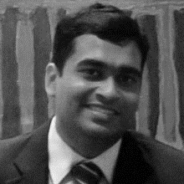
Sasika Gunasekara (2007 batch) Category Demand & Supply Planning Manager - Nestle Zone Asia Oceania & Africa (NDG)
The Chemical and Process Engineering program at University of Moratuwa, was a turning point in my life. It provided me with not just technical skills but also the ability to think critically. The projects and activities helped me to think creatively to find new and efficient solutions to everyday problems, this way of thinking helped me to achieve accelerated growth in my corporate career. The time at university taught me also to respect everyone’s way of thinking and how work can be done together while maintaining that respect. This especially helped me as Nestle is a global multinational, where success depends on the ability to satisfy the needs of everyone in every part of the world.

Gayathri Liyanage (2008 batch) Research Engineer – Industrial Technology Institute (ITI)
The chemical and process engineering program of university of Moratuwa, equipped me with knowledge and confidence to explore new horizons of academic and professional life. It is a very broad discipline which enables one to enter and sustain in numerous different fields. As for me, it opened doors for a career in product development in the apparel sector and then for an academic career with research opportunities in nanotechnology and sustainable energy generation. It also gave me the ability to work closely with international and government organizations related to environmental health and safety and sustainability, such as the Organization for the Prohibition of Chemical Weapons (OPCW)
The friendly and supportive environment of the department helped me immensely to enhance my interpersonal, communication and team working skills which later became very beneficial for my professional career. Further the entrepreneurial and business knowledge transferred through the academic program prepared me to work and in a changing business environment. In conclusion, if someone is really in to the big picture and willing to take up challenges in many different fields, this engineering branch is for you!

Amali Vithanage (2008 batch) Quality and R&D Engineer – Thermo Plastics (Pvt.) Ltd.
Chemical and process engineering, as the name implies it is regarding converting of raw materials in to useful products. In other words, chemical engineer is the person who adds value to pristine raw material or a rubbish which is about to throw away, by following chemical and physical processes. It opens you the paths to food and bio stream, nanotechnology, polymer technology, environmental science, energy engineering, bio medical engineering and many more.
It’s not all about the academic stuff we learn at the university, but about the person we become after going through the degree program. The industry expects engineers who have the self-confidence, novel thinking, leadership and dynamic qualities when it comes to each and every simple task. Finally, when I look back in my past years I see a person who came to the CPE department as a normal student and came out as an engineer with added extraordinary value. So, I invite all of you to grab the opportunity at CPE department to become the dynamic, practical and most preferred engineer by the industry.
Dhanuka Anthony (2011 batch) Head of Operations and Production - Stretchline Holdings, Indonesia
I currently work in the capacity of a Regional Management Trainee-Operation Management for Stretchline Holdings which is a part of the MAS group. I am currently based in Indonesia and will be transferred to the operations in China by the end of the year. Although I am technically not working along the traditional lines of what a Chemical & Process Engineering degree stipulates the amount of relevance is quite high. I was previously working at GSK also as a management trainee.
The best thing about the Chemical and Process Engineering at UOM is that the options it opens are limitless. You can find relevance to almost any industry in at least a few subject matters. This comes as a huge advantage when approaching the job market as it does not limit you to a small number of companies. Especially working in the manufacturing sector Unit Operations, Heat and Mass transfer etc. are subject matter that come in handy at any point in time. Apart from that soft skills improvement is definitely a big advantage in standing out in the job market.

Samavath Mallawarachchi
(2011 batch)
PhD Student – Texas A&M University
Department of Chemical and Process Engineering, University of Moratuwa was the place which laid the foundation for my career as an engineer. The four years spent at the department imbued me with a wide spectrum of knowledge and skills, which prepared me for pursuing a doctoral degree in Biological Engineering. At the end of my undergraduate degree I was able to obtain the gold medal for the highest GPA in DCPE, which I believe is a great achievement. During my years as a graduate student, I have been able to engage in research projects in a variety of areas including drug delivery, enzyme kinetics and molecular simulations. The fundamentals learned at DCPE allowed me to successfully work over multiple research areas. Also it allowed me to look at the research problems in an engineering perspective and see how research can be applied to provide solutions to real life problems.
Department of Chemical and Process Engineering equips its undergraduates with a broad range of knowledge, which allow them to successfully transition into a career path they desire, such as industry or academia or entrepreneurship. Also, our department is blessed with a highly qualified and experienced academic staff who has the potential to bring the best out of students, in both academic and professional aspects. Developing a versatile skillset including technical, critical thinking, communication, and leadership skills to go along with that knowledge would enable DCPE graduates to excel in whatever career they choose.
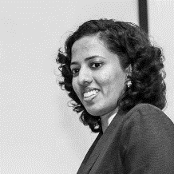
Rochelle Silva
(2013 batch)
PhD Student – Nanyang Technological University, Singapore
The time spent at the Department of Chemical and Process Engineering of the University of Moratuwa will be cherished forever. At DCPE, we were able to gain an overall knowledge about many aspects in the field. For example, while my focus area in the final year was food and biochemical engineering, I was able to gain knowledge about environmental engineering through my research, and about polymer and petroleum engineering through the comprehensive design project. I really appreciate the support given by DCPE family for everything. This encouraged me to pursue extra-curricular activities such as Gavel, Rotaract, ChESS, IEEE WiE and CSM while engaging in academic activities.
If I were to share any tips with the youngsters, I would encourage them to delve deeply into their areas of interest while learning the basics in the curriculum; be it by doing online courses or joining a research project of a senior. Take care of your physical and mental health. Help one another in the journey at the university and beyond– I would like to mention how grateful I am to the peers with whom I studied for exams and to the seniors who helped me adapt to Singapore. It is amazing how the DCPE family stands by us every step of the way if we take the time to reach out.

THE JOURNEY OF DCPE

The Department of Chemical Engineering, being established by gazette notification on 15th February1972 at Katubedda Campus of University of Ceylon, had its roots in the Junior Technical Officer’s course conducted by the Maradana Technical College. Initially the degree program was termed as Chemical Engineering and Fuel Science offering the undergraduates with the degree of Bachelor of Applied Science (B. A. Sc.), which altered into Bachelor of Science of Engineering in 1980.
Being initiated with only 8 students per batch, at present the Department of Chemical and Process Engineering has been progressed to offer the students with the undergraduate degree program in Chemical and Process Engineering for 90 students per batch of each intake to the University of Moratuwa.
Currently, the undergraduate course curriculum has expanded with several minor specialization fields for Environmental and Energy Engineering, Food and Biochemical Engineering, Polymer Engineering and Petrochemical Engineering in order to equip the students with necessary knowledge required for a prospective professional to understand and appreciate the role of a Chemical and Process Engineer in an economy for the sustainable growth.
The continuous growth of well-qualified human resource factor, well-structured course curriculum, well-equipped and well-functioning laboratory facilities, and other supporting resources ensures the improving standard of the internationally recognized programs delivering best professionals.
The department is also improving the bond with the industry during its journey. The internships offered for the undergraduates, the huge career opportunities available for the fresh graduates, the abundance of resource persons for mentoring programs, the facilitators for field visits, the established incubators at the department by the pillars in the industry, and the huge amount of consultancy services required from the department stand proof for the success of the department.

1972 | - Establishment of the Department of Chemical Engineering at the Katubedda Campus of University of Ceylon  - Inauguration of the Department of Chemical Engineering under the Applied Science Faculty offering the Degree of Bachelor of Applied Science (B.A.Sc.)  8 students per batch only were offered with the Degree
1976 | - Graduation of the 1st batch of students from the department
1981 | - Introduction of the Bachelor of Science of Engineering (B.Sc. Eng.) Degree  - The students under E II category were given the opportunity to select Chemical, Material or Mining Engineering fields depending on their 1st year performance in which common subjects were offered to all Engineering disciplines
1986 | - Introduction of M.Sc. course in Polymer Technology as a full-time course
1990 | - Introduction of Polymer Engineering subject to the Chemical Engineering undergraduate curriculum for Final Part III
1991 | - Increment of the student intake up to 15 students per batch  - Introduction of the subject ‘Unit Operation’ to the Part I Chemical Engineering Curriculum
1992 | - Inauguration of Chemical Engineering Society
1993 | - Conducting the three-day open day program “Making the future happen” at department premises and the first issue of ‘Chemunique’ magazine  - Conversion of the fulltime M. Sc. Course in Polymer Technology to a part time course
1994 | - Introduction of the optional subjects Environmental Engineering, Biochemical Engineering and Food Process Engineering to the Chemical Engineering curriculum  - Increment of the student intake up to 20 students per batch
1998 | - Alteration of the title of the Chemical Engineering Department to Department of Chemical and Process Engineering
1999 | - Increment of the student intake up to 30 students per batch
2000 | - Initiation of student intake under a common ‘Engineering’ category Eliminating the E II stream  - Conversion of the course curriculum to semester system from session examinations systems  - Offering of specialization in the field of Chemical and Process Engineering for chosen undergraduates by their Level I academic performance  - Introduction of four fields of minor specialization (presently known as ‘focus areas’) namely, Food & Biochemical Engineering, Environmental Engineering, Energy Engineering and Polymer Engineering  - Increment of the student intake up to 50 students per batch
2001 | - Initiation of Masters program in Chemical and Process Engineering with a first batch of 09 students
2004 | - Inauguration of Chemical Engineering Student Society (ChESS)  - Revision of the course curriculum
2005 | - Re-establishment of the Prof. Hubert Silva Memorial Resource Centre  - Received the IRQUE fund  - Agreement with Hayleys Group to sponsor the annual Gold medal for the best Chemical and Process Engineering Student
2006 | - Foundation stone was laid for the new Chemical Engineering Centre  - Obtaining new equipment under IRQUE grants
2007 | - Initiation of Masters program in Chemical and Process Engineering with a first batch of 12 students in collaboration with Telemark University College, Norway  - Initiation of offering of M.Sc. scholarships for Chemical & Process Engineering students
2008 | - Graduation of first Ph.D. holder  - Signing of agreements with NCPC & Cargills  - Declaring of Opening of Chemical and Process Engineering Centre  - Inauguration of Scholarships Program in Chemical and Process Engineering for students who have economic difficulties
2009 | - Establishment of first food and process development incubator in Sri Lanka  - Establishment of a partnership with Polipto Company – petrol from waste plastics
2010 | - Increment of the student intake further up to 80 students per batch  - Chosen undergraduates were offered with field specialization in Chemical and Process Engineering from Semester II onwards  - Combination of minor specializations of Energy Engineering and Environmental Engineering reducing the minor specializations down to three  - Received accreditation by the IChemE for the undergraduate degree program  - Received accreditation by the IESL for the undergraduate degree program
2011 | - Establishment of SIL-UOM Rubber Products and Process Development Incubator at the Department
2014 | - Initial student credit transfer program with 5 undergraduate students from Telemark University College, Norway
2017 | - Introduction of Petroleum Engineering focus area
2018 | - Signed an MoU with East China University of Science and Technology to boost the academic collaborations between two institutions

ACADEMIC STAFF MEMBERS

The well-qualified and dynamic group of academic staff of the department is the foremost treasure of the department who builds the professionals from the undergraduate’s ready for challenges beyond university life. They provide the students with theoretical, technological and industrial strengths supporting the students’ outlook towards industry. The academic staff members of the Department of Chemical and Process Engineering always strive to develop the department as a place of excellence for the students.
Having a high recognition among the academic community for their contributions towards the betterment of the field, as educators of the chemical and process engineering discipline, the staff members are easily approachable and are ever willing to address student issues, whatever they may be.

HEAD OF THE DEPARTMENT
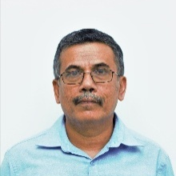 | Prof. Shantha Walpalage  B.Sc. Eng. (Moratuwa), Ph.D. (UK), MIE (SL), C. Eng  E -mail: head-cpe@uom.lk, shanthaw@uom.lk  Phone: +94 112 640 051 Ext: 4101/4105  Direct: +94 112 640 051
SENIOR PROFESSORS
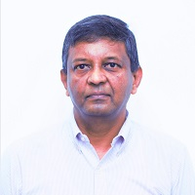 | Prof. Ajith De Alwis  B.Sc. Eng. (Moratuwa), Ph.D. (Cambridge), MBA (PIM-USJP), MAIChe (USA), AMIChemE (UK), AMIESL, FNASSL  E -mail: ajith@uom.lk  Phone: +94 112 640 051 Ext: 4118
PROFESSORS
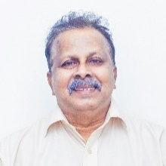 | Eng. Prof. Anul Perera  DSc (RU-USA), B.Sc.(Eng), IntPE (SL), PEng (SL), C. Eng, FIE (SL), MIAChE (USA)  E -mail: anul@uom.lk  Phone: +94 112 640 051 Ext :4122
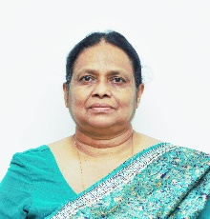 | Prof. (Mrs.) Padma Amarasinghe  B.Sc. Eng.(Moratuwa), M.Sc, Ph.D. (UMIST UK), MIE (SL), C. Eng  E -mail: padma@uom.lk  Phone: +94 112 640 051 Ext :4116
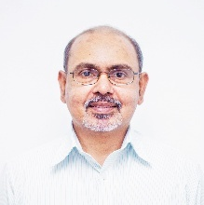 | Prof. Jagath Premachandra  B. Sc. (Col.), M.Sc. (Sri J’Pura), Ph.D. (Cincinnati, USA)  E -mail: jagath@uom.lk  Phone: +94 112 640 051 Ext :4102
Prof. Shantha Amarasinghe
B.Sc. Eng. (Moratuwa), Ph.D. (Cambridge), MIE (SL), C. Eng
E -mail: adusa2@uom.lk
Phone: +94 112 640 051 Ext: 4104
Prof. P. G. Ratnasiri
B.Sc.Eng. (Moratuwa), M.Sc. (UMIST), Ph.D. (NTNU) Norway
E- mail: ratnasiri@uom.lk
Phone: +94 112 640 051 Ext: 4121

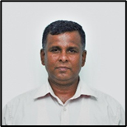 | Prof. Mahinsasa Narayana  C.Eng, MIE (SL), B.Sc. (Eng), MPhil. (Eng.), Ph.D.(UK)  Senior Lecturer Grade II  E-mail: mahinsasa@uom.lk  Phone: +94 112 640 051 Ext: 4107
SENIOR LECTURERS
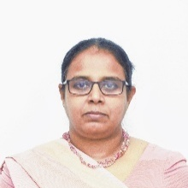 | Dr. (Mrs.) Sanja Gunawardena  B.Sc. Eng. (Moratuwa), Ph.D. (Birmingham), MIE (SL), C. Eng  Senior Lecturer Grade I  E -mail: sanjag@uom.lk  Phone: +94 112 640 051 Ext: 4106
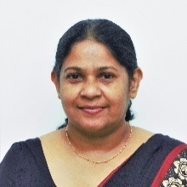 | Dr. (Mrs.) Shantha Egodage  B.Sc. Eng. (Moratuwa), M.Sc. (Moratuwa), M.Phil. (Moratuwa), Ph.D. (Loughborough), MIE (SL), C.Eng  Senior Lecturer Grade I  E -mail: segodage@uom.lk  Phone: +94 112 640 051 Ext: 4120
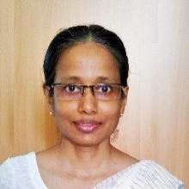 | Dr. (Ms) Manisha Gunasekera  B.Sc. Eng. (Moratuwa), M.Eng. (Moratuwa), Ph.D. (Loughborough), MIE (SL), C. Eng  Senior Lecturer Grade I  E -mail: manisha@uom.lk  Phone: +94 112 640 051 Ext: 4109
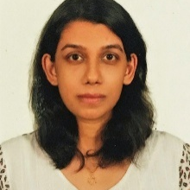 | Dr. (Mrs.) Thilini Ariyadasa  B.Sc. (Hons) (University of Delhi), M.Sc. (Peradeniya), Ph.D. (ICGEB – United Nations)  Senior Lecturer Grade II  E-mail: thilini@uom.lk  Phone: +94 112 640 051 Ext: 4619
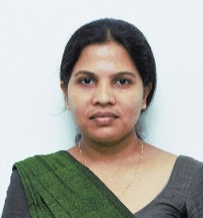 | Dr. Duleeka Gunarathne  B.Sc. Eng. (Moratuwa), MSc., Ph.D.(KTH Sweden)  Senior Lecturer Grade II  E-mail: duleekas@uom.lk  Phone: +94 112 640 051 Ext: 4610
Dr. Thushara Subasinghe
B.Sc Eng. Hons (UoM, Sri Lanka), M.Sc (ZJU, China), Ph.D (ZJU, China), MAIChE
Senior Lecturer Grade II
Email: thusharas@uom.lk
Phone:+94 112 640 051 Ext: 4119
Dr. Mahinsasa Rathnayake
B.Sc. Eng. (Ruhuna), M.Sc (Thammasat), Ph.D (Thammasat)
Senior Lecturer Grade II
E-mail: mratnayake@uom.lk
Phone: +94 112 640 051 Ext: 4591
LECTURERS
Dr. Dilhara Sethunga
B.Sc. Eng. (Moratuwa), Ph.D. (Singapore)
Lecturer (on contract)
E -mail: dilharap@uom.lk
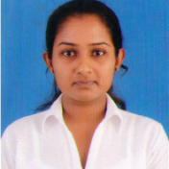 | Ms. Peshalya Kothalawala  M. Sc. (Eng & Tech), B. Sc. Eng. (Moratuwa)  Lecturer (Probationary)  E-mail: peshalyak@uom.lk
Mr. Poorna Vidanage (on study leave)
B. Sc. Eng. (Moratuwa)
Lecturer (Probationary)
E-mail: poornaw@uom.lk
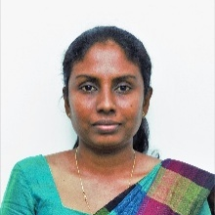 | Ms. Madhurika Geethani  B. Sc. Eng. (Peradeniya)  Lecturer (Probationary)  E-mail: madhurikag@uom.lk
Mr. Susiri Costa
B. Sc. Eng. (Moratuwa)
Lecturer (Probationary)
E-mail: costas@uom.lk

NON-ACADEMIC STAFF MEMBERS
ACADEMIC SUPPORT STAFF
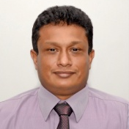 | Mr. Chinthaka Narangoda  B. Sc. (Kelaniya), P. G. Dip in IT (Moratuwa)  System Analyst Grade II  Ext: 4618
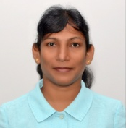 | Mrs. Dinusha Martino  B. Sc. (NS) (OUSL), M. Sc. (Thailand)  Analytical Chemist  Ext: 4613
TECHNICAL STAFF
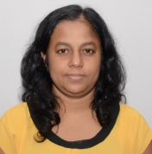 | Mrs. H. B. R. Sajeewani  Staff Technical Officer – Grade I  Ext: 4645
Mrs. Indika Athukorala
Staff Technical Officer – Grade I
Ext: 4160/4625
Mr. B. H. P. Mahendra
Staff Technical Officer – Grade I
Ext: 4614
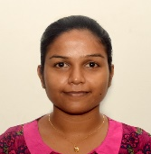 | Ms. Ishara Gayani  NDT (Moratuwa)  Technical Officer Grade II seg A  Ext: 4150
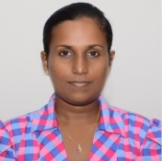 | Mrs. Shameera De Silva  Technical Officer Grade II seg A  Ext: 4644
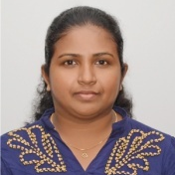 | Ms. Dineshi Rodrigo  Technical Officer Grade II seg A  Ext: 4617
Mr. Dinuka Wijegunarathne
Technical Officer Grade II seg B
Ext: 4659
TECHNICAL ASSISTANCE STAFF
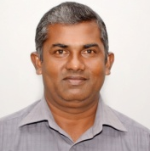 | Mr. B. A. R. D. Abeywardena  Boiler Operator Grade I  Ext: 4620
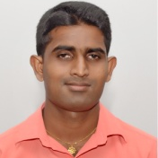 | Mr. Asanka Kumara  Lab Attendant (H.G.)  Ext: 4626/4150
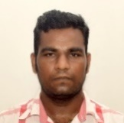 | Mr. S. M. R. N. Dhammika  Lab Attendant (L.G.)  Ext: 4606
Mr. D. S. Dayananda
Lab Attendant (L.G.)
Ext: 4156
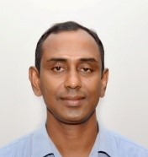 | Mr. B. Karunathilaka  Lab Attendant (L.G.)  Ext: 4625
Mr. Gihan Peiris
Lab Attendant (L.G.)
Ext: 4160

Mr. Viraj Somarathna
Lab Attendant (L.G.)
Ext: 4614
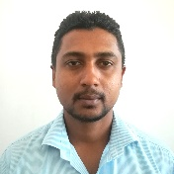 | Mr. Nuwan Gunasekara  Lab Attendant (L.G.)  Ext: 4160
Mr. G. G. Chaminda Kumara
Lab Attendant (L.G.)
Ext: 4160
OFFICE ASSISTANCE STAFF
Ms. Dilrukshi Ranasinghe
Management Assistant Grade III
Ext: 4100
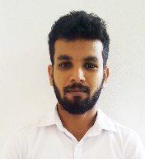 | Mr. Madushan Wijayarathna  Office Assistant  Ext: 4100

UNDERGRADUATE DEGREE PROGRAM

Graduate Program Outcomes Profile

- Engineering Knowledge: Apply knowledge of mathematics, science, engineering fundamentals and an engineering specialization to solve complex engineering problems.

- Problem Analysis: Identify, formulate, research literature and analyze complex engineering problems reaching substantiated conclusions using first principles of mathematics, natural sciences and engineering sciences.

- Design/ development of solutions: Design solutions for complex engineering problems and design systems, components or processes that meet specified needs with appropriate consideration for public health and safety, cultural, societal, and environmental considerations.

- Investigation: Conduct investigations of complex problems using research-based knowledge and research methods including design of experiments, analysis and interpretation of data, and synthesis of information to provide valid conclusions.

- Modern Tool Usage: Create, select and apply appropriate techniques, resources, and modern engineering and IT tools, including prediction and modeling, to complex engineering activities, with an understanding of the limitations.

- The Engineer and Society: Apply reasoning informed by contextual knowledge to assess societal, health, safety, legal and cultural issues and the consequent responsibilities relevant to professional engineering practice.

- Environment and Sustainability: Understand the impact of professional engineering solutions in societal and environmental contexts and demonstrate knowledge of and need for sustainable development.

- Ethics: Apply ethical principles and commit to professional ethics and responsibilities and norms of engineering practice.

- Individual and Teamwork: Function effectively as an individual, and as a member or leader in diverse teams and in multi-disciplinary settings.

- Communication: Communicate effectively on complex engineering activities with the engineering community and with society at large, such as being able to comprehend and write effective reports and design documentation, make effective presentations, and give and receive clear instructions.

- Project Management and Finance: Demonstrate knowledge and understanding of engineering and management principles and apply these to one’s own work, as a member and leader in a team, to manage projects and in multidisciplinary environments.

- Lifelong learning: Recognize the need for, and have the preparation and ability to engage in independent and lifelong learning in the broad context of technological change.

Program Educational Objectives
- To produce graduates who pursue challenging careers, with skills to analyze and provide solutions in energy, environmental, food, polymer and other related industries and emerging areas with an appreciation of the role of Chemical Engineering in the society.
- To produce graduates who pursue advanced studies in Chemical Engineering and related disciplines.
- To create engineering leaders with a global focus, displaying entrepreneurship skills.
Students are selected to follow the B.Sc. in Chemical and Process Engineering (CPE) course based on their performance in semester I examination and their individual preferences. Until 2009, student intake was restricted to 50, which has been increased to 80 in 2010. This was further expanded to 90 in 2013. Currently the department of Chemical and Process Engineering offers four minor specialization streams after completion of their sixth semester, namel;
- Energy and Environmental Engineering
- Food and Biochemical Engineering
- Polymer Engineering
- Petroleum Engineering
Students have the option of following the Chemical and Process Engineering degree program by selecting subjects without any minor stream specialization.
The Department degree program is regularly being revised and renovated under collaborative effort by the academic and industrial personal with the objective of creating highly skilled graduates who meet the needs and demands in both the industry and the academia. Students have the liberty of approaching the department professionals at any time for acquiring necessary knowledge and skills during their stay in the department.

Graduation Credit Requirement
Semester | GPA Credits Normal | Non-GPA Credits
Semester 1 | 15 | 1
Semester 2 | 21.5 | -
Semester 3 | 18.5 | -
Semester 4 | 21 | -
Semester 5 | 19 | -
Industrial Training | - | 6
Semester 6 | 5 | 5
Semester 7 | 18 | -
Semester 8 | 17 | 1

Normal Minimum Credit Requirement
* A minimum total of 150 credits should be completed while completing the following minimum requirements
Overall GPA credits | 135
Overall Non-GPA credits | 13

Semester Coordinators
Academic level | Coordinator
Semester 1 (Dept. Coordinator) | Dr. (Mrs.) Thilini Ariyadasa
Semester 2 | Prof. Shantha Amarasinghe
Semester 3 | Dr. (Ms.) Manisha Gunasekera
Semester 4 | Prof. P.G. Rathnasiri
Semester 5 | Dr. (Mrs.) Duleeka Gunarathne
Industrial Training | Dr. Mahinsasa Rathnayake
Semester 6 | Ms. Peshalya Kothalawala
Semester 7 | Dr. Thushara Subasinghe
Semester 8 | Prof. Mahinsasa Narayana

Teaching and Learning
The knowledge is transferred to the students through a range of learning and teaching activities to fulfil the course objectives. Clearly defined assessment methods are used to measure student’s success in meeting course objectives. Course outline consisting Subject Coordinator, Lecturers, Pre-requisites, Course Objective, Learning Outcome, Tentative Course Outline, Method of Grading, Recommended Textbooks and Selected References for each module is distributed for students at the first lecture of the module.
With the recently established outcome-based education system (OBE), traditional lecture-based teaching and learning system have been diverted to a more student-centred system. Modules are taught through a combination of lectures, practical classes, tutorials, discussions, question and answer sessions, quizzes and take-home assignments. These methods are clearly defined for each module with the learning outcomes of the individual subjects and have been modified such that the student is in an active learning process with more classroom interactions. Subject specific theories, fundamentals and concepts are delivered through lectures, aided by one or combination of; black/white board, overhead projector, multimedia, printed lecture notes and many other learning activities. Students learn by listening, seeing, taking down notes and by discussion. Lecture notes and additional resources are uploaded in Learning Management System (LMS), which is the latest IT based learning environment in University of Moratuwa. Students can access LMS through the following web address.
URL: www.online.mrt.ac.lk
Practical classes carried out in groups, 2-5 students per group, under the guidance of a lecturer and/or an instructor to develop data recording, calculation, analysis and interpretation skills. Tutorials encourage student centred learning towards application of theories to solve chemical engineering problems. Model answers for the tutorials are provided for self-learning.
Assignments, case studies and literature surveys develop a range of skills such as information gathering, identifying lessons and time management. Group or individual activities are introduced to enhance the student interaction with the classroom while maintaining a lively learning process. Group or individual presentations at the end of selected assignments are a means of developing presentation skills from the lecturer’s and the colleagues’ feedback.
Industrial visits are arranged to enunciate the practical applications of theories that are taught during the degree program.
Six months industrial training period at the end Semester 5 enables students to experience in-plant work in an area of their preference within the CPE program. The students develop management skills in addition to the chemical engineering disciplines. Continuous assessment of the training progress is done under the guidance of the Director of the Department of Industrial Training. A student guide for training and training report preparation is available for the student. An E-portal containing information for students which can be accessed through Departmental intranet is in operation. This facility is expected to enhance student’s self-learning abilities.
Research is also an integral component of the pathway of becoming a chemical and process engineer. In the final year, students will be divided into groups of 2 or 3 and they will work on a one-year undergraduate research project with an academic staff member as a supervisor. The students will have the invaluable opportunity to increase their research output by publishing their findings on well-reputed journals and research conferences.
The engineering product design experience is a vital element in engineering education. Students are encouraged to develop a prototype of the designed product, enhancing group learning and innovation. Final year design project allows students to apply their gathered knowledge during first three years in the university to conceptually design a process plant. The final year comprehensive design project consists of a common component where a group of students work on the literature survey, process development and the material and energy balance of an industrial scale plant and an individual component where each student does the detailed design of a major unit in the process.
Examination and Assessment Strategy:
The performance of each student is evaluated solely by either continuous assessments (CA) or a combination of continuous assessments and end of semester examinations (WE).
Continuous Assessments Includes:
- Course work
- Assignments
- Quizzes
- Viva
- Mid-Semester exams
- Presentations and
- Reports.
All candidates should obtain at least 35% from each of CA and WE components to pass a module. This is a University requirement applicable for all modules. The completed assignments must be submitted to the lecturer on the dates of submission as detailed in the assignments. Late submissions will be compensated with reduction of marks.
Students having prolonged illnesses may provide medical reports through the Medical Officer of the university or an equally qualified doctor. Arrangements can be made through negotiation with the lecturer in person to submit assignments. Students having disabilities are encouraged to discuss with the semester coordinates and subject coordinators to make necessary arrangements.
Industrial Training is coordinated and assessed jointly by the DCPE, Industrial training division of UOM and NAITA. The students are partly assessed while undergoing training and any improvement needed to obtain a better training is encouraged at this instance. The student is assessed based on the report submitted at the end, the diary maintained during the training period and a viva assessment.
The final year Comprehensive Design Projects and Research Projects are assessed by the interim reports, final report, presentations, and viva voce examinations.
The marks are displayed on the notice board and the students are given a chance to apply for re-correction. The re-correction application is also allowed for continuous assessment results displayed on the notice board before the end of the semester.
Depending on the credits earned by the student for each module, an Overall Grade Point Average (GPA) is calculated. Each student is awarded a class at the completion of all the graduation requirements within five academic years.
A documentation manual consists of curriculum and syllabi, assessment methods and other relevant information on UG program is available in the Department.

Curriculum

The following description is followed.
C - Core Modules
E - Elective Modules
O - Optional Modules*
*Total of 2 credits to be taken from optional modules in any semester

Module Code | Module Name | Category | Lectures  hrs/week | Lab/ Assignments  hrs/weeks | Credits |  | Norm |  | Evaluation
 |  |  |  |  | GPA | NGPA | GPA | NGPA | CA% | WE%
Semester 1
MA1013 | Mathematics | C | 3.0 | 1/1 | 3.0 | - | 15.0 | 1.0 | 20 | 80
CS1032 | Programming Fundamentals | C | 2.0 | 3/1 | 3.0 | - |  |  | 20 | 80
ME1032 | Mechanics | C | 2.0 | 3/4 | 2.0 | - |  |  | 20 | 80
MT1022 | Properties of Materials | C | 2.0 | 3/4 | 2.0 | - |  |  | 20 | 80
CE1022 | Fluid Mechanics | C | 2.0 | 3/4 | 2.0 | - |  |  | 20 | 80
EE1012 | Electrical Engineering | C | 2.0 | 3/4 | 2.0 | - |  |  | 20 | 80
EL1012 | Language Skill Enhancement I | C | - | 3/1 | 1.0 | - |  |  | 20 | 80
MN1012 | Engineering in Context | C | 1.0 | - | - | 1.0 |  |  | 30 | 70
Total for Semester 1 |  |  |  |  |  |  | 15.0 | 1.0
Semester 2
CH1070 | Chemistry for Engineers | C | 2.0 | 3/2 | 2.5 | - | 19.5 | - | 30 | 70
CH1060 | Process Engineering Fundamentals | C | 2.0 | 3/1 | 3.0 | - |  |  | 40 | 60
CH1050 | Fundamentals of Engineering Thermodynamics | C | 2.0 | 3/2 | 2.5 | - |  |  | 30 | 70
MT2802 | Material Science | C | 2.0 | 3/2 | 2.5 | - |  |  | 30 | 70
ME1090 | Engineering Drawing & Computer Aided Modelling | C | 2.0 | 3/1 | 3.0 | - |  |  | 100 | -
MA1023 | Methods of Mathematics | C | 3.0 | 1/1 | 3.0 | - |  |  | 30 | 70
EN1802 | Basic Electronics | C | 2.0 | 3/4 | 2.0 | - |  |  | 30 | 70
EL1022 | Language Skill Enhancement II | C | - | 3/1 | 1.0 | - |  |  | 30 | 70
DE2xxx | Humanities Elective I | E | - | - | 2.0 | - | 2.0 | -
MN1030 | Entrepreneurship Skill Development (continuing) | O | 0.5 | 3/2 | - | 1.0 | - | - | 70 | 30
Total for Semester 2 |  |  |  |  |  |  | 21.5 | 0.0

Module Code | Module Name | Category | Lectures  hrs/week | Lab/ Assignments  hrs/weeks | Credits |  | Norm |  | Evaluation
 |  |  |  |  | GPA | NGPA | GPA | NGPA | CA% | WE%
Semester 3
CH2100 | Fluid Dynamics | C | 3.0 | 3/2 | 3.5 | - | 18.5 | - | 40 | 60
CH2090 | Chemical Kinetics and Thermodynamics | C | 3.0 | 3/2 | 3.5 | - |  |  | 30 | 70
CH2120 | Biological Science Fundamentals | C | 2.0 | 3/2 | 2.5 | - |  |  | 30 | 70
CH2130 | Polymer Science and Technology | C | 2.0 | 3/2 | 2.5 | - |  |  | 30 | 70
CH2140 | Environmental Science and Technology | C | 2.0 | 3/2 | 2.5 | - |  |  | 30 | 70
MA2013 | Differential Equations | C | 2.0 | - | 2.0 | - |  |  | 30 | 70
MA2023 | Calculus | C | 2.0 | - | 2.0 | - |  |  | 30 | 70
MN1030 | Entrepreneurship Skill Development (continuing from S2) | O | 0.5 | 3/2 | - | 1.0 | - | - | 70 | 30
Total for Semester 3 |  |  |  |  |  |  | 18.5 | 0.0
Semester 4
CH2024 | Unit Operations I | C | 3.0 | 3/1 | 4.0 | - | 19.0 | - | 40 | 60
CH2150 | Particle Technology | C | 3.0 | 3/2 | 3.5 | - |  |  | 40 | 60
CH2014 | Heat and Mass Transfer | C | 3.0 | 3/1 | 4.0 | - |  |  | 40 | 60
CH2110 | Fuel Science and Combustion Technology | C | 3.0 | 3/2 | 3.5 | - |  |  | 40 | 60
MA2033 | Linear Algebra | C | 2.0 | - | 2.0 | - |  |  | 30 | 70
MA3023 | Numerical Methods | C | 2.0 | - | 2.0 | - |  |  | 30 | 70
DE2XXX | Humanities Elective II | E | - | - | 2.0 | - | 2.0 | -
MN 2010 | Entrepreneurial Leadership | O | 1.5 | 3/2 | 2.0 | - | - | - | 50 | 50
Total for Semester 4 |  |  |  |  |  |  | 21.0 | 0.0

Module Code | Module Name | Category | Lectures  hrs/week | Lab/ Assignments  hrs/weeks | Credits |  | Norm |  | Evaluation
 |  |  |  |  | GPA | NGPA | GPA | NGPA | CA% | WE%
Semester 5
CH3143 | Reactor Engineering | C | 3.0 | 3/2 | 3.5 | - | 19.0 | - | 40 | 60
CH3060 | Plant and Equipment Design I | C | 4.0 | 3/2 | 4.5 | - |  |  | 40 | 60
CH3054 | Energy Efficiency and Conservation | C | 2.0 | 3/2 | 2.5 | - |  |  | 40 | 60
CH3044 | Plant Safety and Loss Prevention | C | 2.0 | 3/2 | 2.5 | - |  |  | 40 | 60
MN3052 | Industrial Management & Marketing | C | 2.5 | 3/2 | 3.0 | - |  |  | 30 | 70
MN3042 | Business Economics & Financial Accounting | C | 3.0 | - | 3.0 | - |  |  | 30 | 70
MA3013 | Applied Statistics | O | 2.0 | - | 2.0 | - | - | - | 30 | 70
MN3010 | Multidisciplinary Design, Innovation and Venture Creation | O | 1.5 | 3/2 | 2.0 | - |  |  | 50 | 50
Total for Semester 5 |  |  |  |  |  |  | 19.0 | 0.0
Industrial Training
CH3993 | Industrial Training | C | - | - | - | 6.0 | - | 6.0
Total for Industrial Training |  |  |  |  |  |  |  | 6.0
Semester 6
CH3070 | Plant and Equipment Design II | C | 1.0 | 3/1 | 2.0 | - | 5.0 | - | 40 | 60
CH3080 | Computer Aided Chemical Engineering | C | 1.0 | 6/1 | 3.0 | - |  |  | 100 | -
CH3950 | Technical Report Writing and Presentation Skills | C | 1.0 | 6/1 | - | 3.0 | - | 5.0 | 100 | -
CH3900 | Research Methodology | C | 1.0 | 3/1 | - | 2.0 |  |  | 100 | -

Total for Semester 6 |  |  | 5.0 | 5.0

Module Code | Module Name | Category | Lectures  hrs/week | Lab/ Assignments  hrs/weeks | Credits |  | Norm |  | Evaluation
 |  |  |  |  | GPA | NGPA | GPA | NGPA | CA% | WE%
Semester 7
CH4015 | Comprehensive Design Project I | C | 1.0 | 12/1 | 5.0 | - | 14.0 | - | 100 | -
CH4025 | Process Modelling & Simulation | C | 2.0 | 3/1 | 3.0 | - |  |  | 40 | 60
CH4050 | Unit Operations II | C | 3.0 | 3/1 | 4.0 | - |  |  | 40 | 60
MN4022 | Engineering Economics | C | 2.0 | - | 2.0 | - |  |  | 30 | 70
CH4214 | Environmental Engineering and Management | E | 3.0 | 3/1 | 4.0 | - | 4.0 | - | 40 | 60
CH4224 | Food and Bio Processing | E | 3.0 | 3/1 | 4.0 | - |  |  | 40 | 60
CH4234 | Polymer Processing Operations | E | 3.0 | 3/1 | 4.0 | - |  |  | 40 | 60
ER4810 | Petroleum Geology | E | 1.5 | 3/2 | 2.0 | - |  |  | 30 | 70
CH4350 | Upstream Processing of Crude Petroleum | E | 1.5 | 3/2 | 2.0 | - |  |  | 30 | 70
CH4330 | Process Design and Integration | E | 3.0 | 3/1 | 4.0 | - |  |  | 40 | 60
CH4730 | Research Project (continued in S8) | O | - | 6/1 | - | - | - | - | - | -
MN4062 | Organization Behaviour & Management | O | 2.0 | - | 2.0 | - |  |  | 30 | 70
MA4023 | Operational Research | O | 3.0 | - | 3.0 | - |  |  | 30 | 70
MN4030 | Strategic Enterprise Management | O | 1.5 | 3/2 | 2.0 | - |  |  | 40 | 60
MN3020 | Entrepreneurship Business Basics | O | 2.0 | 3/1 | 3.0 | - |  |  | 50 | 50
MN 4150 | Project Management | O | 2.0 | - | 2.0 | - |  |  | 50 | 50
Total for Semester 7 |  |  |  |  |  |  | 18.0 | 0.0

Module Code | Module Name | Category | Lectures  hrs/week | Lab/  Assignments  hrs/weeks | Credits |  | Norm |  | Evaluation
 |  |  |  |  | GPA | NGPA | GPA | NGPA | CA% | WE%
Semester 8
CH4034 | Comprehensive Design Project II | C | 1.0 | 12/1 | 5.0 | - | 9.0 | - | 100 | -
CH4044 | Process Dynamics and Control | C | 3.0 | 3/1 | 4.0 | - |  |  | 40 | 60
MN4900 | Professional Ethics | C | 1.0 |  | - | 1.0 | - | 1.0 | 100 | -
CH4244 | Clean Technology | E | 3.0 | 3/1 | 4.0 | - | 8.0 | - | 40 | 60
CH4254 | Renewable Energy Engineering | E | 3.0 | 3/1 | 4.0 | - |  |  | 40 | 60
CH4264 | Polymer Engineering and Mold Design | E | 3.0 | 3/1 | 4.0 | - |  |  | 40 | 60
CH4274 | Design of Polymer Products | E | 3.0 | 3/1 | 4.0 | - |  |  | 40 | 60
CH4284 | Food Engineering and Hygienic Plant Design | E | 3.0 | 3/1 | 4.0 | - |  |  | 40 | 60
CH4390 | Biochemical Engineering | E | 3.0 | 3/1 | 4.0 | - |  |  | 40 | 60
CH4340 | Natural Resource Process Engineering | E | 3.0 | 3/1 | 4.0 | - |  |  | 40 | 60
CH4360 | Downstream Processing of Oil, Gas & Petrochemicals | E | 3.0 | 3/1 | 4.0 | - |  |  | 30 | 70
CH4370 | Petroleum Process Operations, Economics, and Law | E | 3.0 | 3/1 | 4.0 | - |  |  | 30 | 70
CH4730 | Research Project (continuing from S7) | O | - | 6/1 | 2.0 | - | - | - | 100 | -
MN4122 | Human Resource Management and Industrial Relations | O | 2.0 | - | 2.0 | - |  |  | 30 | 70
MN4042 | Technology Management | O | 2.0 | - | 2.0 | - |  |  | 30 | 70
MN4112 | Production and Operations Management | O | 2.0 | - | 2.0 | - |  |  | 30 | 70
MN4072 | Small Business Management & Entrepreneurship | O | 2.0 | - | 2.0 | - |  |  | 30 | 70
MN4170 | Global Entrepreneurship | O | 1.5 | 3/2 | 2.0 | - |  |  | 40 | 60
MN4010 | Business Plan Development | O | 1.5 | 3/2 | 2.0 | - |  |  | 70 | 30
MA4013 | Linear Models and Multivariate Statistics | O | 3.0 | - | 3.0 | - |  |  | 30 | 70
MN4800 | Supply Chain Management | O | 2.0 | - | 2.0 | - |  |  | 40 | 60
Total for Semester 8 |  |  |  |  |  |  | 17.0 | 1.0
To be taken from Optional Modules (Any Semester) |  |  |  |  |  |  | 2.0
Minimum Requirement for Graduation (Total of 150 credits)  *Total of 2 credits to be taken from optional modules in any semester  *Total of 2 credits to be taken from optional modules in any semester |  |  |  |  |  |  | 135.0 | 13.0

Requirements for Focus Area
Focus Area | Subject Code | Name | Credits
Energy and Environmental Engineering | CH4214 | Environmental Engineering and Management | 4
 | CH4244 | Clean Technology | 4
 | CH4254 | Renewable Energy Engineering | 4
Food and Biochemical Engineering | CH4224 | Food and Bio Processing | 4
 | CH4284 | Food Engineering and Hygienic Plant Design | 4
 | CH4390 | Biochemical Engineering | 4
Polymer Engineering | CH4234 | Polymer Processing Operations | 4
 | CH4264 | Polymer Engineering and Mold Design | 4
 | CH4274 | Design of Polymer Products | 4
Petroleum Engineering | ER4810 | Petroleum Geology | 2
 | CH4350 | Upstream Processing of Crude Petroleum | 2
 | CH4360 | Downstream Processing of Oil, Gas & Petrochemicals | 4
 | CH4370 | Petroleum Process Operations, Economics, and Law | 4

Requirements for Entrepreneurship Minor
Students following the Chemical and Process Engineering program can obtain a minor in entrepreneurship by fulfilling following subject requirements.
Module Code | Module Name | Category | Lectures  hrs./week | Lab/ Assignments  hrs./weeks | Credits |  | Norm |  | Evaluation  (%)
 |  |  |  |  | GPA | NGPA | GPA | NGPA | CA% | WE%
MN1030 | Entrepreneurship Skill Development | C | 1.0 | 3/1 | - | 2.0 |  | 2.0 | 70 | 30
MN2010 | Entrepreneurial Leadership | C | 1.5 | 3/2 | 2.0 | - | 2.0 | - | 50 | 50
MN3010 | Multidisciplinary Design, Innovation and Venture creation | C | 1.5 | 3/2 | 2.0 | - | 2.0 | - | 50 | 50
MN3020 | Entrepreneurship Business Basics | C | 2.0 | 3/1 | 3.0 | - | 3.0 | - | 50 | 50
MN4010 | Business Plan Development | C | 1.5 | 3/2 | 2.0 | - | 2.0 | - | 70 | 30
MN4022 | Engineering economics | E | 2.0 | - | 2.0 | - |  | - | 30 | 70
MN4030 | Strategic Enterprise Management | E | 1.5 | 3/2 | 2.0 | - | 2.0 | - | 40 | 60
MN4042 | Technology Management | E | 2.0 | - | 2.0 | - |  | - | 30 | 70
MN4112 | Production and Operations Management | E | 2.0 | - | 2.0 | - |  | - | 30 | 70
MN4170 | Global Entrepreneurship | E | 1.5 | 3/2 | 2.0 | - |  | - | 40 | 60

Modules Offered to Other Fields of Specialization
Module Code | Module Name | Category | Lectures  hrs./week | Lab/ Assignments  hrs./weeks | Credits |  | Evaluation  (%)
 |  |  |  |  | GPA | NGPA | CA% | WE%
Semester 4
CH2803 | Process Engineering | E | 1.5 | 3/2 | 2.0 | - | 30 | 70
Semester 8
CH4350 | Petroleum Refining and Petrochemical Industry | E | 1.5 | 3/2 | 2.0 | - | 30 | 70

Modules

Semester II
Module Code | CH1070 | Module Title | Chemistry for Engineers
Credits | 2.5 | Hours/Week | Lectures | 2.0 | Pre – requisites | None
GPA/NGPA | GPA |  | Lab/Assignments | 3/2
Learning Outcomes
After completing this module, the students should be able to;
- LO1 - Identify fundamentals of chemistry including atomic structure, chemical bonding and
chemical& physical properties of substance
- LO2 - Describe principles of electrochemistry to evaluate the interaction between electrical energy
and chemical charge
- LO3 - Describe concepts of organic chemistry to identify different organic reaction mechanisms
- LO4 - Describe principles of natural product chemistry for manufacturing key industrial chemicals
- LO5 - Apply analytical chemistry knowledge in chemical compounds’ quantitative analysis
- LO6 - Identify properties of solutions and calculate the solubility product constant
- LO7 - Apply fundamentals of chemical equilibria for predicting the spontaneity of reactions

Outline Syllabus
- Atomic Structure and Chemical bonding: Atomic structure, Chemical Structure, Shapes of molecules
- Properties of Solids and Liquids: Intermolecular and intra-molecular interactions, Physical Properties
- Properties of Gases: Gas laws, Ideal gas equations, Gas mixtures and partial pressures, Kinetic molecular theory, Molecular effusion and diffusion, Real gases
- Phase Equilibria: Definitions of phase, Component and degrees of freedom, Phase rule and its Derivations, Definition of phase diagram, Phase equilibria for one component system Liquid vapor equilibrium for two component systems, Three component systems
- Properties of Solutions: Factors affecting solubility, solubility constant
- Chemical Equilibria: Criteria of thermodynamic equilibrium, Exoergic and endoergic reactions, Equilibrium constants and their quantitative dependence on temperature, Pressure and concentration, Free energy of mixing and spontaneity, Relations of various equilibrium constants
- Acid base Equilibria: Strengths of acids and bases, Ionization of weak acids and bases, Ionization constants, Ionic product of water
- Electrochemistry: Quantitative aspects of Faraday’s laws of electrolysis, Rules of oxidation/reduction of ions based on half-cell potentials, Chemical cells, Nernst equation; Standard electrode potential
- Applied Organic Chemistry and Reaction Mechanisms: Organic Compounds, Types of organic reactions and their mechanisms, The use of organic reaction mechanisms in industrial applications
- Analytical Chemistry: Quantitative and qualitative analysis, Sampling, Sample preparation and choice of analytical method, Chromatographic techniques; GC, HPLC, Spectrometric methods; IR, UV/visible
- Natural Products and Industrial Applications: Classification of natural products on the basis of chemical structure and their applications

Module Code | CH1060 | Module Title | Process Engineering Fundamentals
Credits | 3.0 | Hours/Week | Lectures | 2.0 | Pre – requisites | None
GPA/NGPA | GPA |  | Lab/Assignments | 3/1
Learning Outcomes
After completing this module, the students should be able to;
- LO1 - Select unit operations necessary for a given process
- LO2 - Identify resources required for a process based on internal and external
constraints
- LO3 - Select the best solving method of material balance for a given subsystem
- LO4 - Estimate resource requirements and process parameters using material and
energy balance
- LO5 - Explain the importance of the steps associated with the process scaling up
applying to the chemical and process industry
- LO6 - Choose the appropriate utility type for a given process.
- LO7 - Develop a process flow sheet

Outline Syllabus
- Introduction to Process Engineering
- Natural resources: Sources of materials; materials from geosphere, hydrosphere atmosphere and biosphere; Sources of energy- renewable and nonrenewable
- Process Development: Concept of process development, design constraints, steps involved in process design
- Unit Operations: Definitions and applications of different unit operations
- Flow sheeting: types of diagrams, instrument identification
- Material Balance: Balances for non-reacting systems and reacting systems with single and multiple reactions
- Energy Balance: Balances for non-reacting systems and reacting systems with single and multiple reactions
- Utilities and instrumentation: Steam production and distribution, types of boilers and steam traps, cooling water and tower, air compressors, positive displacement and dynamic pumps, types of valves, pipes and piping

Module Code | CH1050 | Module Title | Fundamentals of Engineering Thermodynamics
Credits | 2.5 | Hours/Week | Lectures | 2.0 | Pre – requisites | None
GPA/NGPA | GPA |  | Lab/Assignments | 3/2
Learning Outcomes
After completing this module, the students should be able to;
- LO1 - Describe first and second laws of Thermodynamics
- LO2 - Recognize connections between thermodynamics tools and process engineering
- LO3 - Explain the concept of thermodynamic process and describe the different types
of processes
- LO4 - Estimate heat and work quantities and thermal efficiency and the difference
between various forms of energy
- LO5 - Evaluate and distinguish thermal energy conversion in engineering cycles and
devices
- LO6 - Apply thermodynamics for energy balance and designing of processes

Outline Syllabus
- Introduction to Engineering Thermodynamics: The anatomy of thermodynamics, Thermodynamic equilibrium and equilibrium state, Reversible processes
- The First Law of Thermodynamics: Internal energy, Enthalpy, Heat capacity, Application of first law for open systems
- Behavior of Fluids: PVT behavior of fluids, Ideal gas, Compressibility factor
- The Second Law of Thermodynamics: Heat engines and Carnot cycle, Ideal gas Carnot cycle, Absolute temperature scale, Entropy function, Entropy and spontaneity of natural processes, Entropy change, Introduction to open systems, Applications of second law, The third law of thermodynamics
- The Thermodynamic Network: Free energy functions, Clausius inequality and the fundamental equation, Thermodynamic network, Measurable quantities, Calculation of Enthalpy (H) and Entropy (S) as functions of P and T
- Heat Effects: Computational path, Heat effect due to change of Temperature and Pressure, Heat effect due to change of Phase, Mixing heat effect, Enthalpy concentration diagrams, Heat of formation in solution
- Thermodynamics of Pure Substances: Phase diagram, Solid liquid equilibrium, Liquid vapor equilibrium, Thermodynamic property data,
- Refrigeration Cycle: Thermodynamic approach towards refrigeration

Semester III
Module Code | CH2120 | Module Title | Biological Science Fundamentals
Credits | 2.5 | Hours/Week | Lectures | 2.0 | Pre – requisites | None
GPA/NGPA | GPA |  | Lab/Assignments | 3/2
Learning Outcomes
After completing this module, the students should be able to;
- LO1 - Describe major areas and applications in biotechnology
- LO2 - Describe major metabolic pathways and identify the properties of macro/micro
molecules in food chemistry
- LO3 - Describe main classification, structures and functions of microorganisms and their
applications in biotechnology
- LO4 - Describe growth requirements and methods of measuring microbial growth
- LO5 - Identify basic techniques in microbiology/food chemistry
- LO6 - Identify microbial food spoilage methods and apply appropriate control techniques
- LO7 - Describe applications of microbes in process industries

Outline Syllabus
- Introduction to Biotechnology: Definitions, Major areas and Applications
- Techniques in microbiology/food chemistry: Sterile techniques, Culture media, Methods of obtaining pure cultures, Equipment and Instruments
- Food chemistry and metabolic pathways
  - Carbohydrates: Classification, Structure and Function of carbohydrates
  - Proteins: Classification, Structure and Function of proteins
  - Lipids: Classification, Structure and Function of lipids
  - Vitamins & Minerals: Classification, Structure and Functions
  - Enzymes: Classification, Structure, Mechanism of action
- Microbial classification: Naming and Classification of microorganisms
- Structure of microorganisms I: Characteristics and Structure of bacteria, Characteristics and Structure of fungi
- Structure of microorganisms II: General characteristics of virus, Viral structure, Viroid, Prions
- Microbial growth: Growth requirements, Bacterial division, Generation time, Phases of growth, Measurement of growth
- Microbial food spoilage and control methods: Factors influencing growth of microorganisms in food, Food borne diseases, Food preservation
- Application of microbes in process industries I: Fermentation technology, Industrial products- Vitamin production, Enzyme production, Food and beverage production, Antibiotics production, Organic acids production, Amino acids production, Production of single cell proteins
- Application of microbes in process industries II: Biosensors, Bioethanol, Biodiesel, Microbial fuel cells, Bioremediation, Soil microbiology and biogeochemical cycles, Bio pesticides, Biofertilizers, Biofilms, Bio- preservation, Bioterrorism, Bioleaching

Module Code | CH2130 | Module Title | Polymer Science and Technology
Credits | 2.5 | Hours/Week | Lectures | 2.0 | Pre – requisites | None
GPA/NGPA | GPA |  | Lab/Assignments | 3/2
Learning Outcomes
After completing this module, the students should be able to;
- LO1 - Define the basic parameters of polymer science
- LO2 - Categorize polymers into elastomers thermoplastics, thermosets and further
into types to homopolymers and copolymers
- LO3 - Describe a suitable polymerization mechanism for synthesis of a given
polymer
- LO4 - Identify the most suitable polymer/s for a given application
- LO5 - Distinguish the type of latex using their characteristics
- LO6 - Match the product specifications by selecting correct loading of compounding
ingredient/s
- LO7 - Prepare a rubber compound for a given formulation
- LO8 - Explain the importance of using polymer blends and composites over a single
polymer for specific applications

Outline Syllabus
- Classification of polymers
- Polymerization
- Coordination polymerization, ring opening polymerization, polymerization with special catalysts (metallocene)
- Polymerization processes
- Polymer Types
- General characteristics of polymers
- Degradation and stabilization of polymers
- Latex technology
- Structure and property relationships of rubbers
- Rubber Compounding
- Plastic technology
- Surface coatings and adhesives
- Polymer blends and composites

Module Code | CH2090 | Module Title | Chemical Kinetics and Thermodynamics
Credits | 3.5 | Hours/Week | Lectures | 3.0 | Pre – requisites | None
GPA/NGPA | GPA |  | Lab/Assignments | 3/2
Learning Outcomes
After completing this module, the students should be able to;
- LO1 - Explain basic principles of chemical thermodynamics and chemical processes
- LO2 - Describe and understand the chemical equilibrium
- LO3 - Describe and use the concepts of free energy and chemical potential
- LO4 - Understand the application of partial molar quantities
- LO5 - Analyze chemical equilibrium in ideal and non-ideal systems
- LO6 - Apply chemical engineering thermodynamics to chemical engineering unit
operations

Outline Syllabus
- Introduction to Chemical Thermodynamics
- The First Law of Thermodynamics
- Thermodynamics Analysis of Process
- Principles of Phase Equilibrium
- Phase Equilibrium
- Properties of Solutions
- Fugacity
- Chemical Reaction Equilibrium

Module Code | CH2100 | Module Title | Fluid Dynamics
Credits | 3.5 | Hours/Week | Lectures | 3.0 | Pre – requisites | None
GPA/NGPA | GPA |  | Lab/Assignments | 3/2
Learning Outcomes
After completing this module, the students should be able to;
- LO1 - Understand the general concepts of a fluid
- LO2 - Recognize different flow patterns
- LO3 - Explain the fundamentals of fluid flow, different systems of units, dimensional
consistence, and hydrodynamic flow meters
- LO4 - Apply mass, momentum and energy balances
- LO5 - Analyze and solve problems in both compressible and incompressible fluid
flow

Outline Syllabus
- Introduction to Fluid Dynamics
- Mass, Energy, and Momentum Balances
- Fluid Friction in Pipes
- Flow in Chemical Engineering Equipment
- Boundary Layer Theory
- Turbulent Flow
- Introduction to CFD

Module Code | CH2140 | Module Title | Environmental Science and Technology
Credits | 2.5 | Hours/Week | Lectures | 2.0 | Pre – requisites | None
GPA/NGPA | GPA |  | Lab/Assignments | 3/2
Learning Outcomes
After completing this module, the students should be able to;
- LO1 - Identify how environment gets polluted.
- LO2 - Describe basic processes used in wastewater treatment and in air pollution
control in the industry.
- LO3 - Describe basics of solid and hazardous waste management techniques
- LO4 - Identify role of authorities and the industry requirements with respect to
discharge and emission of pollutants in Sri Lanka.
- LO5 - Apply the environmental monitoring systems to understand the environmental
performance.
- LO6 - Analyze reasons behind environmental pollution related problems

Outline Syllabus
- Water Pollution and Wastewater Characteristics
- Wastewater related environmental problems
- Introduction to wastewater treatment processes
- Air Pollution and Atmospheric Pollutants
- Air pollution related environmental problems
- Introduction to Air pollution control equipment
- Basics of Solid and hazardous waste management
- Environmental Monitoring
- National environmental protection regulations

Semester IV
Module Code | CH2014 | Module Title | Heat and Mass Transfer
Credits | 4.0 | Hours/Week | Lectures | 3.0 | Pre – requisites | None
GPA/NGPA | GPA |  | Lab/Assignments | 3/1
Learning Outcomes
After completing this module, the students should be able to;
- LO1 - Recognize the heat and mass transfer related problems in the process industry
- LO2 - Describe basic principles of heat conduction, convection, radiation and heat
transfer with phase change
- LO3 - Describe basic principles of mass transfer
- LO4 - Demonstrate the ability to design heat exchangers
- LO5 - Demonstrate the ability understand the concepts related to mass exchanger
design
- LO6 - Apply mass conservation equation to analyze mass transfer problems
- LO7 - Analyze heat transfer problems using conservation equations

Outline Syllabus
- Heat Conduction
- Steady State Heat Conduction
- Transient Heat Conduction
- Heat Convection
- Force Convection
- Natural Convection
- Heat Transfer with Phase Change
- Thermal Radiation
- Design of Heat Exchangers
- Mass Transfer
- Molecular Mass Transfer
- Convective Mass Transfer
- Design concepts of Mass Exchangers

Module Code | CH2024 | Module Title | Unit Operations I
Credits | 4.0 | Hours/Week | Lectures | 3.0 | Pre – requisites | None
GPA/NGPA | GPA |  | Lab/Assignments | 3/1
Learning Outcomes
After completing this module, the students should be able to;
- LO1 - Identify different methods of binary distillation.
- LO2 - Summarize basic principles of liquid-liquid extraction, leaching, modes of
operation and selection of solvents.
- LO3 - Apply material and energy balance to binary distillation, absorption, stripping
and extraction applications.
- LO4 - Select suitable equipment for mixing, determine power consumption and carry
out scale up calculations.
- LO5 - Evaluate number of theoretical stages in binary distillation, adsorption,
stripping and extraction.

Outline Syllabus
- Introduction to Mass Transfer Operations – Vapor-liquid Equilibrium
- Introduction to Binary Distillation Methods
- Multistage Batch Distillation
- Continuous Distillation with Reflux
- Number of Theoretical Stages for Separation
- Advanced Binary Distillation
- Distillation Analysis by Non-Constant Molar Overflow Methods
- Introduction to Gas Absorption & Stripping
- Determination of Number of Ideal Stages
- Introduction to Solvent Extraction
- Liquid-Liquid Extraction
- Leaching (Solid-Liquid Extraction)
- Super Critical Extraction
- Classification of Mixing Operation
- Liquid Mixing Equipment
- Mechanically Agitated Vessels

Module Code | CH2150 | Module Title | Particle Technology
Credits | 3.5 | Hours/Week | Lectures | 3.0 | Pre – requisites | None
GPA/NGPA | GPA |  | Lab/Assignments | 3/2
Learning Outcomes
After completing this module, the students should be able to;
- LO1 - Derive governing equations for the motion of particle/s in a fluid.
- LO2 - Calculate and Analyze size, shape, size distribution of a particle system.
- LO3 - Develop equations to determine characteristics of fluid flow in packed beds and
fluidized beds.
- LO4 - Design equipment for classification of particles, Solid/Liquid separation and
gas cleaning through the knowledge of particle motion.
- LO5 - Describe fundamentals of Nano-technology and its applications.

Outline Syllabus
- Particle Dynamics
- Particle Statistics
- Flow of fluids through porous solid beds
- Fluidization
- Solid Liquid Separation
- Filtration
- Centrifugation
- Dust and Mist Separation from Gas Streams
- Nano Technology

Module Code | CH2110 | Module Title | Fuel Science and Combustion Technology
Credits | 3.5 | Hours/Week | Lectures | 3.0 | Pre – requisites | None
GPA/NGPA | GPA |  | Lab/Assignments | 3/2
Learning Outcomes
After completing this module, the students should be able to;
- LO1 - Select the required refining processes for specified fuel specifications
- LO2 - Analyze the quality of a given petroleum fraction
- LO3 - Describe basics and principles associated with nuclear energy in nuclear
reactors
- LO4 - Identify suitable lubricant properties required for different lubrication
application conditions
- LO5 - Identify characteristics of solid fuels
- LO6 - Apply combustion theories to calculate energy production by combustion of
fuels in thermal energy producing units.
- LO7 - Design of burners and furnaces

Outline Syllabus
- Properties of fuels
- Petroleum science
- Refinery processes
- Major refinery products
- Solid Fuels
- Nuclear Energy
- Lubrication
- Combustion

Semester V
Module Code | CH3054 | Module Title | Energy Efficiency and Conservation
Credits | 2.5 | Hours/Week | Lectures | 2.0 | Pre – requisites | None
GPA/NGPA | GPA |  | Lab/Assignments | 3/2
Learning Outcomes
After completing this module, the students should be able to;
- LO1 - Evaluate energy projects in the process industry.
- LO2 - Describe methods of energy conversion in the process industry.
- LO3 - Analyze energy systems by performing energy audits.
- LO4 - Identify Energy losses in different energy systems.
- LO5 - Apply the energy recovery methods to maximize energy efficiency of a
process.
- LO6 - Utilize the energy management practices in the process industry.
- LO7 - Derive Environment friendly and sustainable Energy approaches for processes.
- LO8 - Criticize on possible solutions to the existing energy crisis in a constructive
way.
- LO9 - Calculate the energy efficiencies and parameters of Energy Systems by
applying the governing equations for energy engineering, Thermodynamic
principles and chemical aspects.

Outline Syllabus
- Introduction – Energy Problem
- Economics of energy saving schemes
- Energy Conversion
- Energy Recovery
- Energy in buildings
- Combined Heat and Power
- Energy Management Practices

Module Code | CH3044 | Module Title | Plant Safety and Loss Prevention
Credits | 2.5 | Hours/ Week | Lectures | 2.0 | Pre-requisites | None
GPA/NGPA | GPA |  | Lab/Tutorials | 3/2

Learning Outcomes
After completing this module, the student will be able to:
- LO1 - Describe the relationship between safety, health and environmental hazards
associated with work
- LO2 - Describe basic principles related to occupational and process hazards
- LO3 - Discuss basics of safety in plant site layout, operation, maintenance and
modification and basics of incident reporting, investigation and management.
- LO4 - Identify hazards in chemical and process industry.
- LO5 - Identify role of authorities and the industry requirements with respect to health
and safety at work in Sri Lanka and basics of related international practices.
- LO6 - Apply appropriate technologies or measures to reduce occupational hazards
and process hazards
- LO7 - Analyze hazards in chemical and process industry
- LO8 - Evaluate hazards in chemical and process industry

Outline Syllabus
- Introduction to occupational hazards, work, health and productivity
- Toxicity and chemical safety
- Fire, Flammability and Explosion
- Personal protective equipment, Ergonomics, Industrial diseases
- Noise and ventilation, thermal radiation
- Basics of plant layout design for safety and inherent safety
- Safety in plant operation, maintenance and modification
- Identification and quantification of hazards in process plants
- SHE incident and near miss reporting, investigation and management
- Dispersion and distribution of accidental releases to atmosphere
- Legal background: Health and safety at work
- Precautionary principle, responsible care and human factors in safety

Module Code | CH3143 | Module Title | Reactor Engineering
Credits | 3.5 | Hours/ Week | Lectures | 3.0 | Pre-requisites | None
GPA/NGPA | GPA |  | Lab/Tutorials | 3/2

Learning Outcomes
After completing this module, the student should be able to:
- LO1 – Discuss value addition to cheap raw materials by chemical reactions
- LO2 – Design batch reactors, plug flow reactors (PFRs), continuous stirred tank
reactors (CSTRs) and catalytic reactors for the chemical industry.
- LO3 – Compare and select a suitable reactor or a system for an application or a
condition
- LO4 – Analyze chemical reactor performance using the distribution of residence time
- LO5 – Analyze the importance of chemical reactions to mankind

Outline Syllabus
- Mole balances: Batch reactors Continuous- flow reactors, Continuous stirred tank reactors, Tubular reactor, Industrial reactors
- Conversion and reactor sizing: Design equations, Batch systems, Flow systems, Reactors in series
- Rate laws and stoichiometry: The reactor rate constant, The reaction order,
- Constant-Volume reaction systems
- Isothermal reactor design
- Non-isothermal reactor design
- Catalysis and catalytic reactors: Catalysts, Surface reaction, Desorption, Diffusion
- Distributions of residence times for chemical reactors

Module Code | CH3060 | Module Title | Plant and Equipment Design I
Credits | 4.5 | Hours/ Week | Lectures | 4.0 | Pre-requisites | None
GPA/NGPA | GPA |  | Lab/Tutorials | 3/2

Learning Outcomes
After completing this module, the student should be able to:
- LO1 – Gain an understanding of Pressure Vessel Design philosophy
- LO2 – Understand ASME code and use its formulae for economical and safe design of
pressure vessels and its components
- LO3 – Learn how to apply a membrane theory of thin shells of revolution for estimation
of stresses in cylindrical, spherical and conical shells, flat covers, ellipsoidal,
torispherical and toriconical end closures
- LO4 – Estimate the requirements for compensation in openings
- LO5 – Select the type of Supports for vertical and horizontal vessels, Design of base plate
and support lugs, Evaluate anchor bolt requirements, and Design saddle supports
- LO6 – Consider Elastic buckling of long cylinders, buckling modes, Collapse of process
vessels under external pressure, Design for stiffening rings
- LO7 – Design tall towers under combine load at high wind and seismic conditions
- LO8 – Understand the operational principals of common sensors design and recommend
suitable instrumentation for measurement of required process parameters.

Outline Syllabus
- Classification of process equipment
- Structure of ASME Boiler and Pressure Vessel Codes
- Design preliminaries
- Membrane theory of thin shells of revolution under internal pressure
- Compensation for openings
- External pressure vessels
- Pressure vessels under combine load
- Design of skirt supports
- Design of lug supports
- Instruments and Instrumentation system
- Pressure sensors technology and Common pressure transducers
- Temperature scales and temperature measuring instruments
- Basics of flow measurement. differential pressure flow meters

Industrial Training
Module Code | CH3993 | Module Title | Industrial Training
Credits | 6.0 | Hours/Week | - | Pre – requisites | None
GPA/NGPA | NGPA
Aim:
To apply theoretical knowledge satisfactorily to industrial environment, improve practical skills and learn good practices in industry
Learning Outcomes
After completing this module, the students should be able to;
- LO1 – Apply knowledge and principles of chemical and process engineering
- LO2 – Understand industrial systems, procedures, and practices. (i.e., administration, financial, general management, logistics, HSE, legal, etc.)
- LO3 – Design solutions for industrial/engineering problems in the industry using modern tools and techniques. (i.e., Instrumentation, IT tools, software platforms, knowledge-based data, experimental design, etc.)
- LO4 – Develop soft skills, such as teamwork, communication, time management, leadership, and understanding of professional ethics.
Outline syllabus
- Knowledge and principles of chemical and process engineering:
Process flow sheeting, process plant design/maintenance/troubleshooting, Energy efficiency and conservation, Health-Safety-Environmental aspects of chemical processes, Process instrumentation and software platforms/process control systems, Quality control/assurance and analytical testing for process development
- Industrial systems, procedures, and practices:
Administration/financial/general management/logistics/HSE/legal practices in an industrial organization, Practices of professional ethics/personal relations, Organizational practices for process efficiency improvement

Module Code | CH3070 | Module Title | Plant and Equipment design II
Credits | 2.0 | Hours/Week | Lectures | 1 | Pre – requisites | CH3060
GPA/NGPA | GPA |  | Lab/Assignments | 3/1
Learning Outcomes
After completing this module, the students should be able to;
- LO1 – Describe Piping Engineering Fundamentals
- LO2 – Use Piping code for economical and safe design of piping system and its
components
- LO2 – Relate the knowledge in Principals of Fluid Dynamics and Thermodynamics
for designing of turbines and compressors for transmission and power
generation.
- LO4 – Recognize characteristics, capabilities and limitations of heat exchangers
- LO5 – Select suitable heat exchangers for specified applications
- LO6 – Design heat exchangers of improved quality and profitability operation

Outline Syllabus
- Piping Engineering and role of Piping engineer in various field
- Turbo Machines
- Gas Turbine Compressors
- Heat Exchangers

Semester VI

Module Code | CH3900 | Module Title | Research Methodology
Credits | 2.0 | Hours/Week | Lectures | 1 | Pre – requisites | None
GPA/NGPA | NGPA |  | Lab/Assignments | 3/1
Learning Outcomes
After completing this module, the students should be able to;
- LO1 – Understand research experimentation and measurement systems
- LO2 – Use computerized Data-acquisition systems
- LO3 – Apply different sampling and statistical methods
- LO4 – Analyze and interpret data
- LO5 – Plan and document Experiments

Outline Syllabus
- Introduction to research experimentation
- General characteristics of measurement systems
- Computerized Data-Acquisition systems
- Sampling methods and Statistical analysis of experimental data
- Guidelines for planning and documenting experiments

Module Code | CH3080 | Module Title | Computer Aided Chemical Engineering
Credits | 3.0 | Hours/Week | Lectures | 1 | Pre – requisites | None
GPA/NGPA | GPA |  | Lab/Assignments | 6/1
Learning Outcomes
After completing this module, the students should be able to;
- LO1 – Identify limitation of analytical methods for solving chemical and process
engineering problems
- LO2 – Recognize potential of using numerical methods for chemical and process
engineering applications
- LO3 – Recognize suitable software tools for chemical and process engineering
applications
- LO4 – Describe the concept of numerical modeling
- LO5 – Rearrange a process model into a computer model
- LO6 – Apply software tools to analyze chemical and process engineering applications
Outline Syllabus
- SCI LAB
Introduction to use open source software to solve Chemical Engineering problems. Introduction to SCILAB software and basic operations, Polynomials and Curve fitting, Solving of differential equations, Simulation tool box

- ASPEN PLUS
Introduction to the software, Mass Balance on a mixing unit, Material Balance, Modeling and Simulation of a Distillation Column, Modeling and Simulation of a Reactor, Process Economic Analysis, Introduction to Aspen Plus Dynamics

Module Code | CH3950 | Module Title | Technical Report Writing and Presentation Skills
Credits | 3.0 | Hours/Week | Lectures | 1 | Pre – requisites | None
GPA/NGPA | NGPA |  | Lab/Assignments | 6/1
Learning Outcomes
After completing this module, the students should be able to;
- LO1 – Describe the mechanism of an operation / process
- LO2 – Distinguish on informal and formal report writing
- LO3 – Develop informal/ formal laboratory reports for an experiment/ research work
- LO4 – Develop feasibility reports based on the data available
- LO5 – Develop progress reports for a project describing its status
- LO6 – Summarize the content of a technical report to the audience
Outline Syllabus
- Definition - Synonym, formal definitions, classifying the item, differentiating the item
- Describing Mechanisms - Outline for description of a mechanism, definition and purpose, overall appearance, identification of main parts
- Mechanisms in Operation - Outline for describing a mechanism in operation, definition of function, explanation of operating principle
- Describing Processes - Outline for describing a process, description of sequences of action
- Informal Reports and Memoranda - Types of informal reports, informal recommendation reports
- Formal Reports - Outline and the structure of a formal report
- Informal Laboratory Reports - Outline and the structure of an informal laboratory report
- Formal Laboratory Reports - Outline and the structure of a formal laboratory report
- Design Reports - Design reports versus lab reports, design report outline
- Technical Proposals - Technical report structure
- Feasibility Reports - Selecting criteria, feasibility report structure, presenting and interpreting data
- Progress Reports - Progress report structure
- Non – Technical Proposals - Non – technical proposal structure
- Non-Technical Reports - Non – technical report structure
- Oral Reports - Oral and written reports

Semester VII
Module Code | CH4015 | Module Title | Comprehensive Design Project I
Credits | 5.0 | Hours/Week | Lectures | 1 | Pre – requisites | None
GPA/NGPA | GPA |  | Lab/Assignments | 12/1
Learning Outcomes
After completing this module, the students should be able to;
- LO1 - Develop complex design problem-solving skills
- LO2 - Conduct a design project with a significant degree of engineering competence
- LO3 - Conduct a process feasibility study based on a project brief.
- LO4 - Apply mass balance, energy balance to a process plant and Prepare flow sheets
and process flow diagram for the design
- LO5 - Develop technical report writing and presentation skills
- LO6 - Develop skills on working in design teams
Outline Syllabus
- Feasibility study- Economic, risk, safety, health and environmental feasibilities of the selected design
- Site selection and Plant layout
- Material balance calculation for each unit and the complete plant
- Development of the Material flow sheet
- Energy balance calculation
- Development of Energy flow sheets

Module Code | CH4730 | Module Title | Research Project
Credits | 2.0 | Hours/Week | Lectures | - | Pre – requisites | None
GPA/NGPA | GPA |  | Lab/Assignments | 6/1
Learning Outcomes
After completing this module, the students should be able to;
- LO1 – Review literature critically and identify research gaps/problem
- LO2 – Develop new experimental set ups/ models/strategies
- LO3 – Construct new ideas or approaches independently
- LO4 – Develop self-integrity under challenging environment
- LO5 – Analyze data obtained from experiment or modelling and drawn conclusions
- LO6 – Evaluate results in the context of related literature
- LO7 – Produce research findings as a published material
Outline Syllabus
- Introduction to research methodologies
- Literature review
- Problem identification and finding alternative solutions
- Methodology development with developing an experimental rig, demonstration models and/ or mathematical models
- Results analysis

Module Code | CH4025 | Module Title | Process Modelling and Simulation
Credits | 3.0 | Hours/Week | Lectures | 2.0 | Pre – requisites | None
GPA/NGPA | GPA |  | Lab/Assignments | 3/1
Learning Outcomes
After completing this module, the students should be able to;
- LO1 – Describe systems and models, main elements of dynamic modelling.
- LO2 – Identify process parameters to develop a mathematical model of a system.
- LO3 – Construct state space models and linearize non-linear systems.
- LO4 – Develop numerical models of a process and build up computer models for
simulations by using computer aided tools (MATLAB/SIMULINK).
- LO5 – Evaluate dynamics of the systems and processes
- LO6 – Analyze and optimize processes by using simulation studies.

Outline Syllabus
- System and Model
- Energy balance
- Spatial description and the mass balance
- Species and substances
- The momentum balances
- The energy balances
- Temperature profile from the energy balance
- Energy balance for a CSTR
- Energy balance for a gas storage and transportation.
- Comparison of energy forms
- Laplace transformation, Transfer function
- Solution of linear models
- Analysis of models
- Numerical methods

Module Code | CH4050 | Module Title | Unit Operations II
Credits | 4.0 | Hours/Week | Lectures | 3 | Pre – requisites | CH2024
GPA/NGPA | GPA |  | Lab/Assignments | 3/1
Learning Outcomes
After completing this module, the students should be able to;
- LO1 – Describe principles in Unit operations (multi-component distillation,
humidification, crystallization, adsorption, evaporation and drying)
- LO2 – Select suitable mode of operation and equipment for a given separation process
covered under the module
- LO3 – Apply material and energy balance to the process equipment
- LO4 – Analyze a given separation process and perform chemical engineering design
calculations
- LO5 – Design tray and packed distillation columns and column internals

Outline Syllabus
- Distillation: Multi-component Distillation Bubble point and dew point calculations of multi-component mixture, Multi-component flash Distillation., Column Distillation, Key components, Fenske equation, Underwood equation, Approximate short cut methods and exact calculation procedures, Design of tray and packed distillation columns and column internals.
- Evaporation: Single and Multiple effect evaporators, area calculations, Heat and mass balance, Evaporation equipment, Vapor recompression in multiple effect evaporators.

- Adsorption: Types of adsorbents, Adsorption equilibrium, modes of adsorption, single stage, cross flow, countercurrent and fixed adsorption unit design calculations, Breakthrough curves, adsorption regeneration

- Humidification Operations: Mechanism for Humidification operations, Simultaneous heat and mass transfer, Adiabatic and non-adiabatic operations. Equipment used for the operation and size calculations.

- Crystallization: Principles of crystallization, Nucleation, Kinetics of crystallization, Heat and mass balance, yield, equipment and design calculations

- Drying: Use of psychometric charts, Vapor - gas mixtures and their properties, Principles of drying, Rate of drying, critical moisture content and falling rate period Mechanism of drying processes, Heat and Mass transfer in drying processes, Batch and continuous drying, Equipment sizing and selection.
Module Code | CH4214 | Module Title | Environmental Engineering and Management
Credits | 4.0 | Hours/Week | Lectures | 3 | Pre – requisites | CH2140
GPA/NGPA | GPA |  | Lab/Assignments | 3/1
Learning Outcomes
After completing this module, the students should be able to;
- LO1 – Discuss environmental management systems
- LO2 – Describe international protocols related to global environmental problems
- LO3 – Apply environmental accounting in project analysis
- LO4 – Formulate solid and hazardous waste management strategies for given cases
- LO5 – Assess environmental impacts
- LO6 – Select suitable pollution control techniques for a pollution control system
- LO7 – Design environmental pollution control equipment to meet discharge standards

Outline Syllabus
- Wastewater Engineering
- Air Pollution Control
- Solid Waste Management and Engineering
- Hazardous Waste Management
- History of Environmental Management and Development of Quality Management
- Greening of the supply chain
- Environmental impact assessment principles and process;
- Methods of assessing environmental impacts
- Basics of Environmental Accounting
- Environmental Management Systems
- International protocols related to global environmental problems

Module Code | CH4224 | Module Title | Food and Bio Processing
Credits | 4.0 | Hours/Week | Lectures | 3 | Pre – requisites | CH2120
GPA/NGPA | GPA |  | Lab/Assignments | 3/1
Learning Outcomes
After completing this module, the students should be able to;
- LO1 – Evaluate food processing techniques and preservation methods.
- LO2 – Calculate and Model temperature, time, nutrients level, microbial destruction in
different thermal technologies.
- LO3 – Derive equations on microbial and enzyme kinetics
- LO4 – Design biological reactors and processes through the knowledge of microbial
kinetics.
- LO5 – Describe the use and the applications of enzymes in the industry.
Outline Syllabus
- Introduction to Food and Bio Processing
- Food Preservation and Shelf Life
- Thermal Processing of Food
- Thermal Process Calculations
- Thermal Process Methods
- Low Temperature Operations
- Food Packaging
- Introduction to Bioprocess Engineering
- Microbial Growth Kinetics
- Fermentation Systems
- Enzyme Kinetics
- Bio Hazards and Bio-safety

Module Code | CH4234 | Module Title | Polymer Processing Operations
Credits | 4.0 | Hours/Week | Lectures | 3 | Pre – requisites | None
GPA/NGPA | GPA |  | Lab/Assignments | 3/1
Learning Outcomes
After completing this module, the students should be able to;
- LO1 – Identify and describe the polymer processing operations related to latex,
rubber and plastic processing
- LO2 – Discuss the influence and importance of processing parameters on polymer
operations
- LO3 – Apply rheological and heat transfer principles to optimize the polymer
processing operations
- LO4 – Recognize the machineries used for polymer processing
- LO5 – Analyze products defects that can be appeared during respective polymer
processing operations
- LO6 – Demonstrate the ability to select the most appropriate processing technique(s)
for a newly design polymer product to manufacture

Outline Syllabus
- Heat transfer ion polymer systems
- Rubber Processing Techniques - Mastication, mixing, cross-linking, forming/ shaping; extrusion, calendaring and molding
- Determination of processing characteristic and rheological properties
- Plastic Processing Techniques- Molding, Extrusion, Calendaring, Casting and forming
- Latex processing techniques- Dipping, Foaming, Casting and thread manufacturing
Basic calculations of selected polymer processing equipment

Module Code | CH4350 | Module Title | Upstream Processing of Crude Petroleum
Credits | 2.0 | Hours/Week | Lectures | 1.5 | Pre – requisites | None
GPA/NGPA | GPA |  | Lab/Assignments | 3/2
Learning Outcomes
After completing this module, the students should be able to,
- LO1 – Explain Formation, Composition and Characterization of Crude Petroleum
- LO2 – Describe Separation of Product Fluids
- LO3 – Explain Treatment of Produced Fluids
- LO4 – Describe Field Processing and Treatment of Natural Gas
Outline Syllabus
Analysis of Crude Petroleum
- Oil and Gas: From Formation to Production
- Composition and Characteristics of Crude Petroleum

Separation of Produced Fluids
- Two-Phase Gas–Oil Separation
- Three-Phase Oil–Water–Gas Separation

Treatment of Produced Fluids:
- Emulsion Treatment and Dehydration of Crude Oil
- Desalting of Crude Oil
- Crude Oil Stabilization and Sweetening
- Storage Tanks and Other Field Facilities
- Produced Water Treatment

Field Processing and Treatment of Natural Gas
- Overview of Gas Field Processing
- Sour Gas Treating
- Gas Dehydration
- Separation, and Fractionation of Crude Oil
- Natural Gas Liquids

Module Code | CH4330 | Module Title | Process Design and Integration
Credits | 4.0 | Hours/Week | Lectures | 3 | Pre – requisites | None
GPA/NGPA | GPA |  | Lab/Assignments | 3/1
Learning Outcomes
After completing this module, the students should be able to;
- LO1 –Describe and Distinguish process design methods.
- LO2 – Conduct process economics when selecting utilities and infrastructures.
- LO3 – Apply Pinch analysis to optimize heat recovery in a process.
- LO4 – Evaluate Utility Systems.
- LO5 – Design Heat Exchanger networks.
- LO6 – Perform pinch analysis for Reactors, Distillation Columns and Evaporators.
- LO7 – Demonstrate the ability to use software tools to design processes.

Outline Syllabus
- Introduction to Process Design and Integration
- Introduction to Pinch Analysis
- Pinch Analysis Calculations I
- Pinch Analysis Calculations II
- Pinch analysis and Heat recovery
- Heat Exchanger Network Design I
- Heat Exchanger Network Design II
- Heat Exchanger Network Design III
- Combined Heat and Power generations
- Heat Integration of reactors
- Heat Integration of Separators
- Process Economics
- Introduction to Simulation
- Tools for Process Design

Module Code | CH4034 | Module Title | Comprehensive Design Project II
Credits | 5.0 | Hours/Week | Lectures | 1 | Pre – requisites | CH4015
GPA/NGPA | GPA |  | Lab/Assignments | 12/1
Learning Outcomes
After completing this module, the students should be able to;
- LO1 – Appraise key decisions to be made and relevant assessment criteria for
equipment selection
- LO2 – Design a selected process equipment in detail, including chemical, mechanical
and operational aspects
- LO3 – Identify the type of material and method of fabrication suitable for the
equipment
- LO4 – Select control schemes and instrumentation
- LO5 – Describe the startup, shut down, operational, and maintenance procedure
- LO6 – Analyze safety and economic aspects of the equipment
- LO7 – Develop technical report writing and drawing skills

Outline Syllabus
Students will work individually to perform detail design of a selected process equipment in the plant studied under CH4015 module.
- Selection of appropriate equipment
- Revisit Mass Balance and Energy Balance
- Calculation of dimensions of the unit
- Mechanical design
- Selection of material
- Thickness calculation
- Internals, supports and others
- Description of fabrication
- Mechanical drawings
- Piping and Instrumentation
- Startup- Shut down
- Safety and Control
- Others- Economic aspects etc.

Semester VIII

Module Code | CH4044 | Module Title | Process Dynamics and Control
Credits | 4.0 | Hours/Week | Lectures | 3 | Pre – requisites | None
GPA/NGPA | GPA |  | Lab/Assignments | 3/1
Learning Outcomes
After completing this module, the students should be able to;
- LO1 – Describe the behavior of 1st, 2nd and higher order dynamical systems.
- LO2 – Analyze linear dynamical systems using mathematical tools such as Laplace
transforms etc.
- LO3 – Set up simple feedback loops using PID controllers and development of
control modules
- LO4 – Implement various PID tuning methods for controllers
- LO5 – Design and Develop feedback and feed-forward controllers and obtain a
hands-on experience in doing this via simulation and experimentally on lab
scale apparatus by using LabVIEW.

Outline Syllabus
- Introduction to Process Dynamics & Control
- Dynamic Behavior and Linear State Space Models
- Transfer Functions and Empirical Models
- Introduction to Feedback Control
- PID Controller Tuning
- Auto-tuning Techniques
- Controller equipment
- Frequency-Response Analysis
- Various control methods and control structures
- Cascade and Feed-Forward Control
- Control-Loop Interaction
- Plant wide Control
- Fuzzy logic control system

Module Code | CH4244 | Module Title | Clean Technology
Credits | 4.0 | Hours/Week | Lectures | 3 | Pre – requisites | None
GPA/NGPA | GPA |  | Lab/Assignments | 3/1
Learning Outcomes
After completing this module, the students should be able to;
- LO1 – Identify resource recovery techniques for waste
- LO2 – Describe recycling techniques
- LO3 – Apply source reduction, waste minimization, energy efficient improvements and
process integration solutions for pollution prevention/ minimization in industry.
- LO4 – Apply clean technologies in the process industry.
- LO5 – Select environmentally friendly processes and technologies.
- LO6 – Analyze environmentally friendly product and process designs
- LO7 – Assess cleaner production in the process industry

Outline Syllabus
- Introduction to Clean Technology
- Energy Efficiency Improvements
- Introduction to the Concept of Cleaner Production
- Cleaner Production Assessment
- Eco design
- Source Reduction and Waste Minimization
- Resource recovery from waste; recycling techniques
- Process integration solutions for waste avoidance
- Life Cycle Assessment (LCA)
- Process and technology selection
- Carbon foot print and water foot print
- GHG emission reduction or removal enhancement
- Good manufacturing practices, Eco efficiency
- Clean Technology Case Studies

Module Code | CH4254 | Module Title | Renewable Energy Engineering
Credits | 4.0 | Hours/Week | Lectures | 3 | Pre – requisites | None
GPA/NGPA | GPA |  | Lab/Assignments | 3/1
Learning Outcomes
After completing this module, the students should be able to;
- LO1 – Recognize renewable resources in Sri Lanka
- LO2 – Describe applications of renewable energy.
- LO3 – Demonstrate the ability to design renewable energy system for practical
applications
- LO4 – Understand optimization of renewable energy utilizations with the available
energy resources
- LO5 – Analyze viability of renewable energy systems
- LO6 – Design and implement of a renewable energy system

Outline Syllabus
- Introduction of Biomass and biofuels
- Power from the wind
- Solar Energy
- Hydro-power
- Energy systems, storage and transmission

Module Code | CH 4264 | Module Title | Polymer Engineering & Mold Design
Credits | 4.0 | Hours/Week | Lectures | 3 | Pre – requisites | CH2130
GPA/NGPA | GPA |  | Lab/Assignments | 3/1
Learning Outcomes
After completing this module, the students should be able to;
- LO1 – Identify and describe the important engineering principles applicable to
polymers.
- LO2 – Discuss the influence and importance of engineering properties on physical
testing of polymers.
- LO3 – Apply knowledge gains on polymer engineering to optimize the manufacture
of polymer products.
- LO4 – Recognize the software used for design and fabrication of molds for polymer
products
- LO5 – Demonstrate the ability to design simple mold/die to manufacture polymer
product
- LO6 – Design a mold and die for a defined product

Outline Syllabus
- Rubber-like elasticity
- Polymer Rheology
- Viscoelastic properties of polymers
- Facture Mechanics of polymers
- Design of molds for polymer products
- Design of extruder dies
- Computer Aided Design Analysis and Fabrication of Molds

Module Code | CH4274 | Module Title | Design of Polymer Products
Credits | 4.0 | Hours/Week | Lectures | 3 | Pre - requisites | CH2130  CH4234
GPA/NGPA | GPA |  | Lab/Assignments | 3/1
Learning Outcomes
After completing this module, the students should be able to;
- LO1 – Apply the knowledge on the various properties of polymers in selecting
suitable polymers.
- LO2 – Analyze the processing characteristics and optimize the required properties for
polymer products
- LO3 – Select the suitable processing conditions to manufacture defect-free products
- LO4 – Identify failure mechanisms of polymer products used under different service
environments.
- LO5 – Describe assembly techniques required for designing and manufacturing of
polymer products
- LO6 – Design of simple engineering polymer products

Outline Syllabus

- Basic design concepts
- Features and assemblies of commodity and engineering rubber products
- Modes of deformation
- Basic calculation on designing of simple engineering products
- Design of plastic products
- Determination of average molar mass and molar mass distribution
- Solution properties of polymers
- Analysis of polymers by chromatography and spectroscopy
- Mechanical properties of polymers
- Determination of thermal properties of polymers
- Processing characteristics of polymer
- Surface properties and morphology of polymer
- Determination of electrical properties of polymers

Module Code | CH4284 | Module Title | Food Engineering and Hygienic Plant Design
Credits | 4.0 | Hours/Week | Lectures | 3 | Pre – requisites | CH2120  CH4224
GPA/NGPA | GPA |  | Lab/Assignments | 3/1
Learning Outcomes
After completing this module, the students should be able to;
  - LO1 – Demonstrate knowledge on common food processing and preservation
techniques for safe and quality food production
  - LO2 – Develop an awareness on the modern food chain (supply chain process, food
legislation, and various tech-economic issues)
  - LO3 – Develop simple understanding on nutrition and dietetics
  - LO4 – Design plant and equipment which is in agreement with standards and
guidelines for hygienic design
  - LO5 – Apply hygienic standards in operations and maintenance

Outline Syllabus
- Basic principles of human nutrition
- Food engineering operations
- Food plant operations and supply chain issues
- Future trends in food processing
- Hygienic practices
- Hygienic plant design
- Hygienic equipment design
- Verification and certification of hygienic food processing plants

Module Code | CH4390 | Module Title | Biochemical Engineering
Credits | 4 | Hours/Week | Lectures | 3 | Pre – requisites | CH2120  CH4224
GPA/NGPA | GPA |  | Lab/Assignments | 3/1
Learning Outcomes
After completing this module, the students should be able to;
- LO1– Explain techniques used for generating genetically modified microorganisms to
synthesize bio-based products
- LO2 – Evaluate different cell cultivation methods, bioreactors and modes of
operation.
- LO3 – Estimate the sterilization requirement of media and equipment.
- LO4 – design suitable reactors for cell culture with mixing, determine power
consumption, and carry out scale up calculations.
- LO5 – Select appropriate instrumentation and controls in cell culture
- LO6 – Evaluate separation techniques used in bio-industry

Outline Syllabus
- Isolation of industrially important microorganisms
- Gene expression and protein synthesis in microorganisms
- Genetically modified/engineered micro organisms
- Industrial applications of genetically engineered organisms
- Medium Formulation, cell nutrients
- Stoichiometry of microbial growth and product formation
- Sterilization of fermentation media and air
- Sterilization kinetics
- Cell cultivation
- Bioreactors – modes of operation, types of reactors, design of agitated bioreactors, design of agitated bioreactors, measurements, instrumentation and control, aeration and agitation in bioreactors, scale-up criteria for bioreactors
- Recovery and purification of bio-products
- Fermentation economics

Module Code | CH4340 | Module Title | Natural Resource Process Engineering
Credits | 4.0 | Hours/Week | Lectures | 3 | Pre – requisites | None
GPA/NGPA | GPA |  | Lab/Assignments | 3/1
Learning Outcomes
After completing this module, the students should be able to;
- LO1 – Understand the availability of natural resources for industrial use
- LO2 – Explain currently available processes to convert natural resources to value added
products
- LO3 – Develop processes to add value to natural resources available in Sri Lanka
- LO4 – Develop Socio, Economic, Technical and Financial Evaluation of Industrial
Processes
- LO5 – Identify safety, health and environmental aspects of industrial processes
Outline Syllabus
- Introduction to natural resources
- Value added products
- Value addition processes
- Safety- Health and Environmental Impact
- Process feasibility
- Socio-economic impacts
- Value addition for waste by products

Module Code | CH4360 | Module Title | Downstream Processing of Oil, Gas & Petrochemicals
Credits | 4.0 | Hours/Week | Lectures | 3 | Pre – requisites | CH2110
GPA/NGPA | GPA |  | Lab/Assignments | 3/1
Learning Outcomes
After completing this module, the students should be able to;
- LO1 – Select suitable hydrocarbon fuels for different applications
- LO2 – Describe functionalities of Production Processes and Technologies to produce
hydrocarbon fuels based on their applications
- LO3 – Describe production routes &processes for the synthesis of petrochemicals
and their derivatives.
- LO4 – Perform material and energy balance calculations for the production
processes.

Outline Syllabus
Idealization of Petroleum products
- Automotive Fuels - Volatilities, combustion characteristics
- Fuels for Power Generation - Combustion characteristics, handling properties
- Solvents – Volatilities, Characterization
- Lubrication Oils – Characterization and Applications
- Waxes and bitumen - Types properties and uses
Liquid Fuel Processing
- Petroleum Refining - Refinery Processes and Processing [Distillation – Atmospheric& vacuum, Thermal Processing, Catalytic Processing],
- Conditioning & Polishing Processes,
- Product Handling, Utilities Management,
- HSE Management Systems
Gaseous Fuel Processing
- Principles of Gas conditioning and Processing
- Transport Processes and Separation Process
- Cryogenic & Compression Operations in Gas Processing.
- Storage and Product Handling.
Petrochemical Processing
- Classes of Petrochemicals and their Production Processes
- Petrochemicals and their derivatives; Polymers, Base Chemicals and Fertilizers

Module Code | CH4370 | Module Title | Petroleum Process Operations, Economics, and Law
Credits | 4.0 | Hours/Week | Lectures | 3 | Pre – requisites | CH4193 CH3044
GPA/NGPA | GPA |  | Lab/Assignments | 3/1
Learning Outcomes
After completing this module, the students should be able to;
- LO1 – Evaluate current trends in oil and gas industry
- LO2 – Analyze economics of Petroleum Processing
- LO3 – Describe Laws pertaining to Petroleum Operations
- LO4 – Design Procedures for Safe Operation of Petroleum Processing facilities
Outline Syllabus
Trends in Petroleum Industry
- National legal instruments related to petroleum oil and gas industry;
- International standards, guidelines and directives related to oil and gas industry, Exploration & Production,
- Effects of Regional Politics and Activities towards Petroleum Industry

Economics of Petroleum Processing
- Trends in Petroleum Industry-
- Financial instruments,
- Commercial Operations in Petroleum Industry

Petroleum Law
- Local Laws Pertaining to Petroleum Industry
- International Laws Pertaining to Petroleum Industry
- Case Studies

Safe Operation of Petroleum Facilities
- Introduction to Process Safety in oil & gas facilities,
- Safety Instrumented systems (SIS),
- Emergency shutdown (ESD) systems,
- Design of Systems for Safe Operations

Module Code | CH4350 | Module Title | Petroleum Refining and Petrochemical Industry
Credits | 2.0 | Hours/Week | Lectures | 1.5 | Pre – requisites | None
GPA/NGPA | GPA |  | Lab/Assignments | 1.5
Learning Outcomes
After completing this module, the students should be able to;
- LO1 – Describe production processes for petrochemicals
- LO2 – Select required refining processes for specified fuel specifications
- LO3 – Select suitable fuels for specific applications
Outline Syllabus
Petroleum Refining
- Refinery Configurations
- Thermal & Catalytic Processes
- Refinery Offsite Facilities
- Refining economics

Petroleum Product Characterization

- Liquid Fuel Characterization
- Gaseous Fuel Characterization,
- Transportation and Storage of Fuels

Petrochemical Processing
- Classes of Petrochemicals and their Production Processes
- Petrochemicals and their derivatives; Polymers, Base Chemicals and Fertilizers

Note: Offered to ER students

Research

Research, being an integral part of the curriculum of undergraduate and postgraduate studies, not only boosts the research potential of the students but also benefits the field of Chemical and Process Engineering through the flow of huge contribution of better solutions and innovative ideas into it. Food and biochemical engineering, Polymer science engineering, and Environmental engineering can be mentioned as the main fields of research studies that undergraduate and graduate students focus on. The availability of well-functioning and well-equipped laboratory facilities intensifies the value of the experimental work and research activities conducted by both undergraduate and postgraduate students.
CH 4730 – Research Project is the foundation of being a researcher at the undergraduate level in the department. Successful completion of the module will allow students to identify research gaps/problems by reviewing the available literature in a critical manner, develop new strategies or experimental set ups owing to the requirement and availability, construct new approaches in an independent manner, analyse the results obtained and derive possible conclusions from the study, evaluate the obtained results in the context of related literature, and finally deliver key research findings as a published material in well-recognized journals and either national or international symposiums such as, Moratuwa Engineering Research Conference (MERCon), Annual Sessions of The Institution of Engineering, Sri Lanka, International Symposium on Agriculture and Environment, etc.
Postgraduate students would have the opportunity to carry out their programs focusing on the fields including, Environmental and Energy Engineering, Food and Biochemical Engineering, Polymer Engineering, Petroleum Engineering as well as Computational Process Dynamics. M.Sc., M.Phil., and Ph.D. degrees conducted by the department will provide the opportunity to engage in full –time research programs with a better learning environment to acquire knowledge and the experience essential for a postgraduate.
Research and Development unit which has been jointly set up by the DSI Samson group also lead to encourage either undergraduate or postgraduate students to engage in certain projects by providing much-valued intellectual input required. Further, department offers a series of research projects to grant the industry with enhancing innovations and better solutions for the sustainable development of the industry and the country.
Some of the key areas covered by the recently carried out research projects are,
- Computational fluid dynamics modeling of thermo-chemical processes
- Numerical simulations of biomass combustion and gasification processes
- Improving Astaxanthin production yield from photosynthetic microalgae
- Application of absorption and extraction techniques on wastewater treatment
- CO₂ capture and Airborne Pollution Control using industrial solid waste

- Identification of best blend composition of natural rubber – thermoplastics blends for industrial applications
- Life Cycle Assessment of bio-fuel and sustainable energy production processes
- Implementation of process control techniques and analyses on process
optimization
- Effects of using natural fillers on mechanical properties of rubber
- Dynamic modeling and simulation of anaerobic digestion processes for solid waste management
- Assessment of sustainable energy potential of renewable resources
- Biomass-based renewable energy systems
- Parameter optimization of chemical processes

Comprehensive Design Project

CH4015, CH4034 – Comprehensive Design Project is the ultimate course for the B.Sc. Chemical Engineering Degree. It will allow the students to bring together much of their previously learnt engineering knowledge on a real, practical problem. It contributes 10 credits gained in semesters 6, 7 and 8.
The project is also quite different from the majority of the subjects that the students will be doing in the initial semester. It is a team effort and an open-ended project, where student get the opportunity to work as a team on open-ended projects with real industrial complications. Communication amongst members is vital. There is no ‘’right’’ solution! - Just the “best” solution in the time available.
One of the goals of this subject is to introduce students to an industrial periphery where real life processes and problems will have to be addressed. The academic staff will endeavour to give advice and support as the student proceed in the project. The group will be managed by its members. There needs to be a leader who co-ordinates activities. It is the responsibility of the group members to ensure that the project progresses at an appropriate rate. Good communication within the group is essential and this will be reflected in your final report. It will show the students’ effort at teamwork and communication ability. As a UGC accredited B.Sc. Chemical Engineering degree program, DCPE places a high priority on this subject as part of your entry into the profession.
- In this unit, student will be encouraged and facilitated to develop the ability and desire to: Work as a team on open ended problems within tight time constraints in such a way that all members contribute individually as well as collectively with proper communication
- Apply fundamental chemical and environmental engineering principles and available data from literature to design and analyse chemical processes
- Make critical design decisions in a safe, creative, practical and cost-effective manner
- Report the work in formal, concise, and in an organized manner

Industrial Training

As a partial fulfillment of the B. Sc. in Chemical and Process Engineering degree program, at the end of semester 5 it is compulsory for students to register for the Industrial Training Module during the 6th Semester. Under this Module students are placed in a real industrial environment for 24 weeks period of time. Industrial Training module has been designed to provide industrial experience for the students. This is the first and the last opportunity given for working in an industry as a budding Chemical and Process Engineer before the student gets their degree qualifications.
In order to have background knowledge about Industrial Training and to make Industrial Training more fruitful, a series of presentations are arranged in Semester 5. In these presentations invited experts from industry address the students on the topic "How to get the maximum benefit of Industrial Training with the intention for having a successful future carrier." In addition, senior Process Senior engineering students who have been to Industrial Training also make presentations and share their industrial experience with. Further, the Industrial Training Coordinator of the Department facilitates the students in industrial training placement process.
In the Industrial Training program, the student is supposed to use the theoretical and experimental knowledge gained as an undergraduate in the industrial environment and to improve the practical skills, management skills and interpersonal skills. Development of these skills is highly important to become a qualified engineer. Further, the student is educated about important areas such as product manufacturing processes, treatment processes, process design, process modification, process optimization, problem identification and problem solving.
During the stay in an industry the student is supposed to manage a technical diary and a handbook covering the engineering, technical and managerial matters. Student’s performance on Industrial Training is closely monitored and examined by a member of the academic staff, Industrial Training Division and NAITA, by visiting the relevant industry. After successful completion of the training program, students are supposed to submit a technical report on their training to the Industrial Training Division and the same to the DCPE. In line with that, students have to present their training experience before a panel of academic staff at the DCPE. There, students’ level of knowledge and experience on industrial training are evaluated. Finally, progress in industrial training is evaluated through a viva voce & a presentation (individual) by a panel comprising a member of academic staff of DCPE, a member of Industrial Training Division and a member of NAITA.
Some of the companies where industrial training is offered,
- Ceylon Petroleum Corporation
- Unilever Sri Lanka Limited
- Hemas Holdings PLC
- Industrial Solutions Lanka (Pvt) Ltd
- Ansell Lanka (Pvt) Ltd
- Sri Lanka Institute of Nanotechnology
- Lanka Sugar Company (Pvt) Limited
- Nestle Lanka PLC
- JAT Holdings (Pvt) Limited
- Ceylon Biscuits Limited
- GlaxoSmithKline Pharmaceuticals Ltd
- Ceylon Cold Stores

- Avery Dennison Lanka (Pvt) Limited
- Renuka Agri Foods PLC
- Trelleborg Lanka (Pvt) Limited
- Chevron Lubricants Lanka (Pvt) Limited
- Phoenix Industries Limited
- Norochcholai Lakvijaya Power Plant
- Siam City Cement (Lanka) Limited

Awards Available for DCPE Students
Award Ceremony Convocation Awards
Thusitha Senevirathne Memorial Scholarship
Awarded for the CPE undergraduate who has obtained the highest GPA in the first attempt in Level 3 Semester 1 Examinations, provided that the student obtains an Overall GPA of 3.7 or above.
Thusitha Senevirathne Memorial Award
Awarded for the CPE undergraduate who is specializing in the field of Environmental Engineering and has obtained the highest GPA in Level 3 and Level 4 at the first attempt, provided that the student obtains an Overall GPA of 3.7 or above
Unilever Award
The CPE undergraduate who obtains the highest marks for the Final Year Comprehensive Design Project, provided that he obtains a grade A receives this award.
Dr. Mahesh Amalean award
This prestigious award is given to the best final year undergraduate research project of the Department of Chemical and Process Engineering, provided the group of students obtain a grade of ‘A’ or above.

Gold Medal awarded by the Hayleys Group
Awarded to the undergraduate of the DCPE who obtains the highest Overall GPA at the BSc. Engineering Degree Examination, provided that the student obtains an Overall GPA of 3.8 or above and is awarded at the General Convocation.
Most Outstanding Graduand of the year
This prestigious awarded is presented to the most outstanding graduate of the year of the Faculty of Engineering and is awarded at the General Convocation. The awardee is expected to displaying an exceptional academic standing with a GPA exceeding 3.7; First Class Honors, also demonstrating excellent leadership qualities, and also a person who has made a significant contribution through participation and service to the university and community.
Vidya Jyothi Professor Dayantha S. Wijeyesekera Award
This prestigious awarded is presented to the most outstanding graduate of the year of the University of Moratuwa and is awarded at the General Convocation. The awardee is expected to displaying an exceptional academic standing with a GPA exceeding 3.7; First Class Honors, also demonstrating excellent leadership qualities, and also a person who has made a significant contribution through participation and service to the university and community.

INDUSTRY COLLABORATION

Mentoring
Mentoring is to support and encourage students to manage their own learning and behavioural while maximizing and enhancing their potential, soft-skills, performance, and becoming a competent and a self-confident person. Unique and distinguished industrial personals from related industries are connected with students through the department in order for the students to get an intimate experience in the industry surroundings. During a period of 13 weeks in semester IV, each group of students are assigned a mentor and students travel to the mentor’s organization. Some of the key elements focused by the mentors are leadership skills, communication skills, teamwork, attitude, etiquette, and personal grooming. This course provides the students a virtuous opportunity to extend themselves as a well- rounded person who are well equipped for the future.
Department Industry Consultative Board Meeting (DICB)
Department Industry Consultative Board (DICB) Meeting aids the department to meet industry representatives from several recognized industries. This has benefits for both parties. While the department seeks industry expertise to revise and renew its curriculum to meet the dynamic demand in the field, industry get the assistance of the department to address their various problematic situations.
Consultancy Services
The department is at all times approached by the industry to seek solutions for their problems and to assist in enhancing their performance. Department might act like a third party in assisting them while sometimes directly engaged in the research and development work under a contract with the interested party. Students who are enthusiastic in engaging in these works might have a chance to work with the academic staff and gain an invaluable knowledge and experience.
Field Visits
The department arranges field visits for their students to visit the industries and get an insight of the processes, working environment and the knowledge. This allows the students to expand their knowledge and experience which otherwise would be limited to lectures and books.
Among the most recent field visit destinations are,
- Lakvijaya Power Station, Norochcholai,
- Phoenix Industries Ltd., Makandura
- Lanka Sugar Company, Sewanagala
- Nestlé Manufacturing Facility, Pannala
- Lion Brewery PLC, Biyagama

Incubators
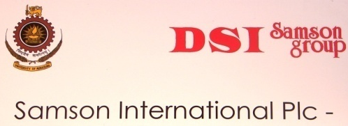
SIL-UOM Rubber Products and Process Development Incubator

UOM-SIL Rubber Products and Process Development Incubator is a model for the University and Sri Lankan industry partnerships in research and development. It was established in the DCPE in the year 2011 in collaboration with Samsons International PLC. Later, Samson Compounds (Pvt) Ltd. joined as a partner of the Incubator. D. Samson Industries (Pvt) Ltd. also became a partner of the Incubator in December 2019.
The Incubator is a common platform on which the University academics and members of the research and development divisions in the DSI group of companies engage in the development of rubber products and manufacturing processes. The projects undertaken by the Incubator includes trouble shooting, problem solving, new product & process development and process modification. In addition, some projects are related to environmental problem solving, energy minimization and value addition for wastes. Further, development of commercially viable products or processes, development of new formulas and processes to manufacture the existing products to be competitive in the market and modifying the existing quality control and assurance procedures are some of the other tasks of this Incubator. Research engineers and research chemists are carrying out research in this regard under the supervision of University academics. They perform their research activities at the partner Industries as well as in the laboratories of the DCPE.
Undergraduates following the B. Sc. Engineering in Chemical and Process Engineering degree are also benefitted by the UOM-SIL Rubber Products and Process Development Incubator. They can obtain the real industrial exposure and improve their theoretical knowledge and practical skills by participating research and development activities. In addition, they are able enhance the ability of analytical thinking and the capacity of innovation.

SPECIAL EVENTS AND PROGRAM
Annual General Meeting
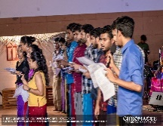
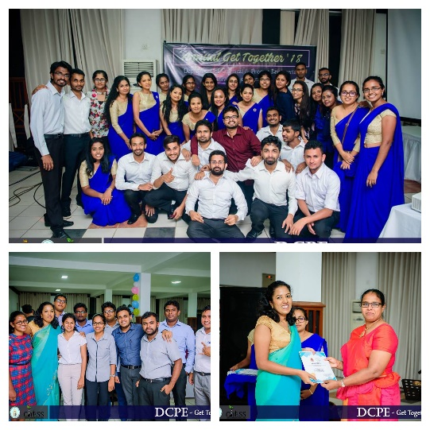
Annual gathering of Chemical and Process Engineers of University of Moratuwa is organized by the ChESS with the participation of department’s undergraduate, graduates, academic staff and the representatives from the industries. Most recently, the 2018 event was held at Sri Lanka Foundation Institute. The night with magnanimous meetings with industrial leading characters passed out from University of Moratuwa was a precious occasion for chemical and Process Undergraduates to meet their role models.

Yaye Padura
An evening with glorious musical spills over the “Yaye Padura” which is another foremost event annually functioning at the Chemical and Process Engineering department court yard, organized by the fresh siblings of the department family in order to facilitate the interaction between undergraduate students of the Department as well as to make a stage to express instrumental, vocal and dancing talents of department students and staff.
‘EXORIOR’
the Latin word “Exorior” narrates exuberant actions like rising up, coming forward and cheering. As the name proposes, the event Exorior is a vigorous full day program organized to provide a prodigious platform for our undergraduates to develop their team building skills including leadership skills, creative thinking and interpersonal skills by actively participating in team activities and interacting with each other in a friendly and enthusiastic environment.
Most recently the 2018 event was organized under the theme, ‘Awaken the leader within you’. The program was held with the presence of undergraduates of Level 02, 03 and 04, post graduate students, non-academic staff and the academic staff. The agenda consisted of various activities, which helped each and every participant to improve his/her abilities and skills in areas of teamwork and personality development. All the participants irrespective of their age or level spent a day full of friendship and life and were able to gain a glimpse of experiences and strengthen their bonds.
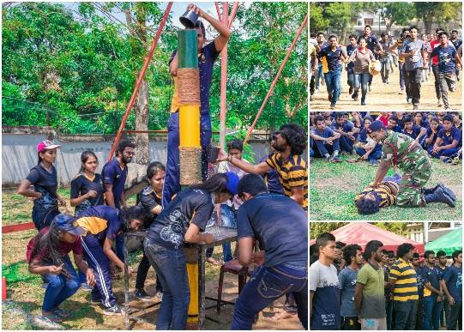
CPE Sports Fiesta
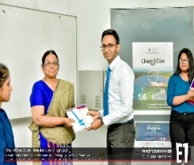
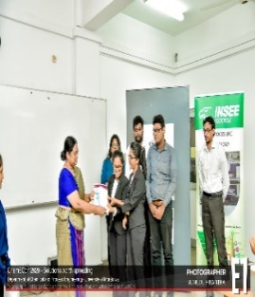
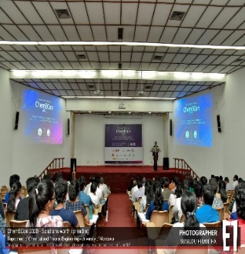
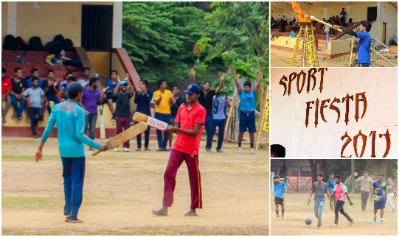
Another annual interactive event organizing by the Level 02 students of the department of Chemical and Process Engineering is CPE Sports Fiesta. This is a sports day that brings all the joys, bonds, freedom and an inestimable change from the impassable academic matters for all students, Academic and Non-academic staff family members of DCPE.

Chemical Engineering Conference (ChemECon)
This event focuses on portraying the potential of undergraduates and fresh graduates in the Chemical and Process Engineering Department of University of Moratuwa.
The primary objective of the event being bridging the gap between industry and university research and innovation arena in the field of Chemical and Process Engineering, the event showcases the final year research studies and industrial projects conducted by the students of the department.
For the first time ChemECon 2020 was held under the theme of “Solution worth spreading”. The event comprised of three sessions; the main event and two breakout sessions which were held parallelly on the day of the event. The breakout sessions were conducted under two themes, “Product and process optimization” and “Sustainable technologies & environmental remediation” which focused on two separate areas in the chemical and process industry. The ‘Union Chemicals Award for the Best Presentation’ was also awarded in all breakout sessions.

SOCIETIES

Chemical Engineering Society (ChES)
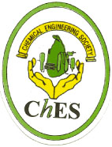

The Chemical Engineering Society was formed in 1993 with the objective of increasing awareness of Chemical Engineering in the country. It is hence dedicated in promoting more collaborative work with local industries. The Society was registered as a specially authorized society under Societies Ordinance on 22nd September 1995 (Reg. S. 4822). Its membership consists of 259 members including present and past chemical engineering students, employed in both local and international institutions and industries.
Specific objectives other than this primary objective of the society includes,
- To provide opportunities for the dissemination and exchange of knowledge and experience primarily among professionals of Chemical and Process Engineering and also, among the industrialists, the public and society at large
- To promote the rational and economic development of Chemical Engineering science and technology in the country so as to ensure the best interests of the community as a whole
- To encourage research, development and training in Chemical and Process Engineering
- To promote among its members high standards of technical proficiency, professional expertise and professional ethics so as to enhance in turn the profession of Chemical and Process Engineering
- To collaborate with other organizations: national and international, in activities relating to furtherance of the ChES objectives
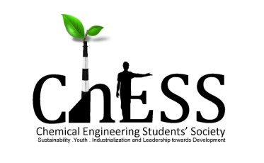
Chemical Engineering Student Society (ChESS)
The Chemical Engineering Student Society was formed in year 2004. It is dedicated to building a responsibility among undergraduates to integrate social concerns into their academic lives. Through a variety of interdisciplinary activities, focusing on leadership development and interactive learning, ChESS at UoM strives to work together with industrial, social and student communities.
Specific objectives of the ChESS include,
- Enhancing the involvement of the Chemical and Process Engineering students in industry related activities and projects
- Improving the interaction with the society through socially beneficial activities
- Sharing knowledge with school children through interactive activities and projects
Activities
- Organizing the Annual General Meeting, of DCPE, providing a great opportunity for the members of the CPE family to interact with each other. At the AGM undergraduates and postgraduates have the opportunity to meet each other as well as their dearest academic staff.
- Annually publication of the magazine "Chemunique" which has a wide circulation.

Research for Undergraduates (R4U) Club
The Research for Undergraduates Club was initiated in 2019, with the aim of providing a better understanding on research and its importance to DCPE’s undergraduates. The intention of the club is to perform as a knowledge sharing platform, by providing guidance to enhance research skills of the club members through workshops, lectures, peer mentoring, networking with research communities and by providing hand-on experience in research. Through these activities, it is expected to develop personal and academic skills of club members, which in turn would create positive impacts on further development of the country.
Objectives of R4U include,
- Providing opportunities for the club members to get exposure to the area of research and to enhance their research skills/improve knowledge.
- Guiding members to engage in research through workshops, lectures, peer mentoring and networking with the research community.
- Providing guidance to conduct research and publish the research outcomes.
- Supporting academic and personal development of the club members.
Activities
- Explorer, an interactive series of sessions conducted to spread awareness to club members about the opportunities and pathways available beyond the discipline of chemical and process engineering.
- The R4U club acts as a platform to link available research projects and club members, thereby facilitating hands-on experience in research work and teamwork.
Alumni Association
The Alumni Association of the DCPE is the hub that reconnects all passed out graduates of the department, young and old. Its prime objective is to enhance a continuing relationship between the department and its older generations. Alumni membership is open to all graduates from the department.

LABORATORY FACILITIES AND RESOURCES
Laboratory Facilities
The Department of Chemical and Process Engineering is proud to have a well-equipped and well-functioning set of laboratories which facilitate both undergraduates and postgraduate students with their experimental work and research. At present, the department is in the process of establishing new laboratory facilities for petrochemical engineering with modern state of art technologies. The assistance of the competent and the well-qualified technical officers and the technical assistance staff members for the experimental work and research activities is also significant.

Unit Operations/ Pilot Plant Laboratory
Lecturer in Charge: Prof. (Mrs.) Padma Amarasinghe
Technical Officer: Mr. B. H. P. Mahendra
Boiler Operator: Mr B. A. R. D. Abeywardena
Lab Attendant: Mr. Viraj Somarathna
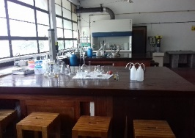
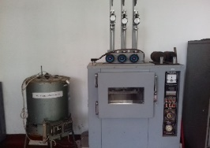
Unit operations are the basic physical operations of Chemical Engineering. The Unit Operations Laboratory of the department is well-equipped to conduct both laboratory scale and pilot scale experiments, allowing students to gain hands-on experience with the fundamental principles and practical applications of chemical engineering. The apparatus for distillation, evaporation, crystallisation, heat transfer, retort processing, filter press, fluidized bed, mixing and centrifugation and are few of the outstanding equipment in the laboratory.

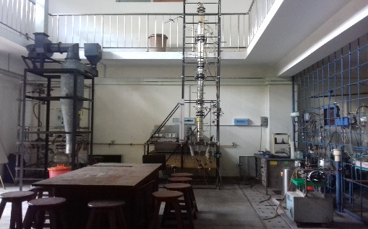
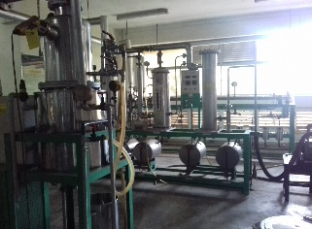
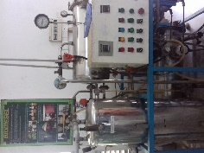

Polymer Physical Testing and Latex Laboratory
Lecturer in Charge: Prof. Jagath Premachandra
Technical Officer: Mrs. Shameera De Silva Lab Attendant: Mr. D. S. Dayananda
The Latex Technology Laboratory of the department is equipped with latex characterization instruments for latex product manufacture while it is also equipped with several instruments to measure chemicall properties of polymer. Also, instrumentation to analyse various properties of rubber and plastic such as physical, mechanical and thermal properties namely; specific gravity, rebound resilience, tensile and compression, abrasion resistance, melt flow index and other are available in this laboratory
Process Control Laboratory
Lecturer in Charge: Prof. Mahinsasa Narayana
Technical Officer: Mrs. H. B. R. Sajeewani
Lab Attendant: Mr. D. S. Dayananda
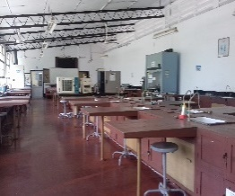
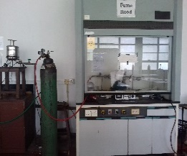
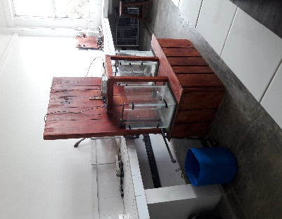
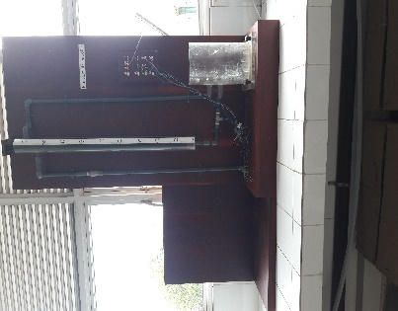
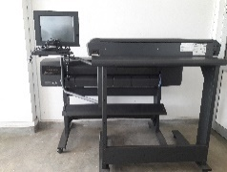
Designing and operation of processes that are safe, meet the production requirements with high quality with profit are the premier objectives of a Chemical and Process Engineer. Therefore, the process instrumentation and control are vital aspects to be mastered by the students. The Process Instrumentation and Control Laboratory of the department is equipped with various process modelling and simulation facilities such as process simulator, numerical control, process feedback control study unit to enhance the student competencies.

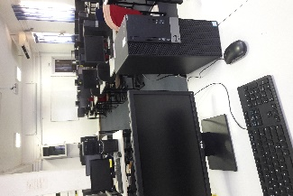
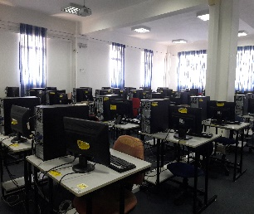
Industrial Chemistry Laboratory
Lecturer in Charge: Prof. Jagath Premachandra
Technical Officer: Mrs. Indika Athukorala
Lab Attendant: Mr. Gihan Peiris
The Industrial Chemistry Laboratory supports many course modules for both undergraduate and postgraduate studies through several experimental setups and by facilitating research activities. Furthermore, it is equipped with two major pilot scale reactors which are important in reactor engineering namely, Continuously Stirred Tank Reactor (CSTR) and Batch Reactor.

CAPD /CAM Centre
Lecturer in Charge: Prof. Mahinsasa Narayana
System Analyst : Mr. Chinthaka Narangoda
Technical Officer: Mrs. H. B. R. Sajeewani
Lab Attendant: Mr. Asanka Kumara
The centre facilitates the studies with experience on many process simulation applications. It is being used to offer many useful software packages such as AutoCAD, SolidWorks, LabVIEW, MATLAB and Simulink, Scilab, Aspen Plus etc. that are particularly useful in the industry of Chemical and Process Engineering. The centre supports the academic activities also providing the internet access to gather necessary resources for their studies.
Environmental Engineering Laboratory
Lecturer in Charge: Prof. P. G. Rathnasiri
Technical Officer: Ms. Dineshi Rodrigo
Lab Attendant: Mr. Chaminda Kumara
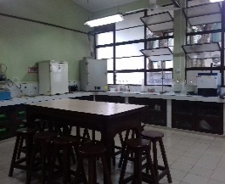
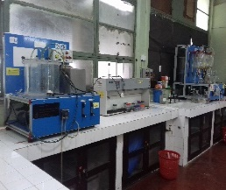
The Environmental Engineering Laboratory facilitates necessary experience and knowledge in environmental engineering. It is equipped with lab scale and pilot scale equipment facilities related in wastewater and solid waste treatment. Facilities are available to determine key parameters related in water/wastewater analysis. Pilot scale experimental setups are available to conduct experiments under aerobic and anaerobic waste treatment processes. Furthermore, online data acquisition and monitoring of anaerobic waste treatment processes are conducted using newly automated reactor systems.

Transport Phenomena Laboratory
Lecturer in Charge: Prof. Shantha Amarasinghe
Technical Officer: Mr. B. H. P. Mahendra
Lab Attendant: Mr. Viraj Somarathna
Transport Phenomena Laboratory has been developed as an undergraduate teaching laboratory. Main focus is to demonstrate the fundamental concepts in heat, mass and momentum transport. Students are encouraged to learn through hands-on experiences. Rankine Cycler is the latest arrival to the lab. Students are able to understand the fundamentals of steam power generation and to become familiar with the associated thermodynamic principles and efficiencies of the Rankine power cycle. The laboratory is further equipped with the following teaching units,
- Flow measurement unit
- Centrifugal pump demonstration unit
- Equipment Test Bench to Study Analogy between fluid friction and heat transfer
- Apparatus for determining heat loss from bare and lagged pipes
- Computer controlled gaseous mass transfer and diffusion coefficient unit
- Computer controlled liquid mass transfer and diffusion coefficient unit
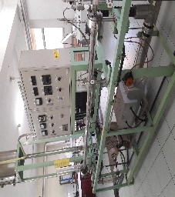
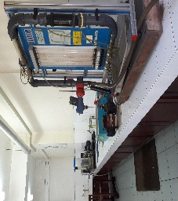
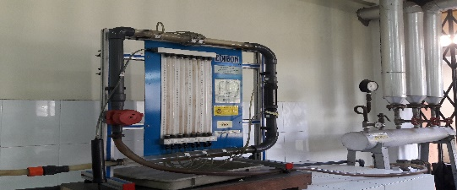

Polymer Processing Laboratory
Lecturer in Charge: Dr. (Mrs.) Shantha Egodage
Technical Officer: Mrs. Shameera De Silva Lab Attendant: Mr. U. K. D. D. N. Gunasekara

The Polymer Processing Laboratory provides the students with the opportunity to gain experience in polymer processing techniques. This laboratory offers a wide range of pilot plant scale machinery for mixing and subsequent processing of both plastic and rubber, including an injection molding machine (plastic), blow molding machine (plastic), extruders with single and double screws (plastic), hot feed extruder (rubber), internal mixer, two-roll mill, plasticorder, presses, oscillating disc rheometer and processability testing equipment.
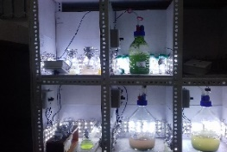
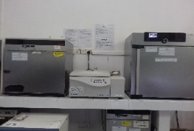
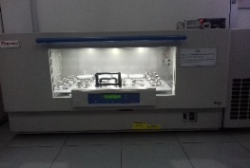
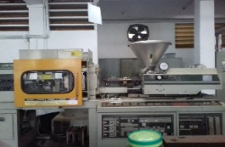
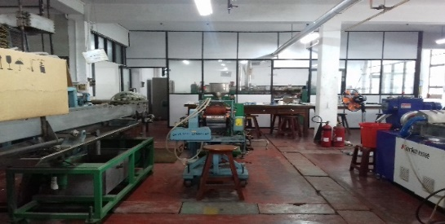
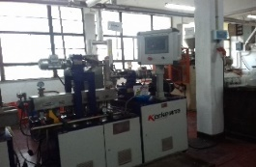

Food Engineering Laboratory
Lecturer in Charge: Ms. Peshalya Kothalawala
Technical Officer: Mrs. Ishara Gayani
Lab Attendant: Mr. Asanka Kumara

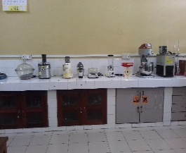
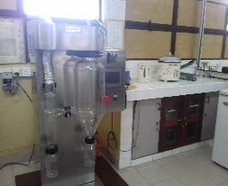
Food Engineering Laboratory facilitates the students with experimental and research work on food-bio chemistry, and food process engineering. The laboratory is equipped with a spray dryer, retort sterilizer, freeze dryer, fruit juice extractor, dough mixer and other ancillary units required in food processing.
Microbiology Laboratory
Lecturer in Charge: Dr. (Mrs.) Thilini Ariyadasa
Technical Officer: Mrs. Indika. Athukorala
Lab Attendant: Mr. B. Karunathilake
Microbiology Laboratory of DCPE is focused on understanding the diverse cellular and metabolic processes of microbes for the production of pharmaceuticals, chemicals and energy. The laboratory is equipped with Autoclave, Incubators, Incubator shakers, Centrifuges, Colony counter, Class II biosafety cabinet, -20ºC Freezer and also state of the art equipment including PCR, horizontal Gel electrophoresis system, Gel documentation system and microscopy core facilities essential for the advance research in the area of Metabolic Engineering.
Analytical Instruments Centre
Lecturer in Charge: Prof. Jagath Premachandra
Technical Officer: Mr. Dinuka Wijegunarathne
Lab Attendant: Mr. Gihan Peiris

Instrumentation is vital for proper measurement and controlling of processes. The Process Instrument Centre of the Department consists of advanced modern analytical measurements. The Gas Chromatograph, High Performance Liquid Chromatograph, Differential Scanning calorimeter, Particle Size Analyser and UV Spectrophotometer are among these instruments. This centre provides a combination of testing facilities for academia and industrial purposes.
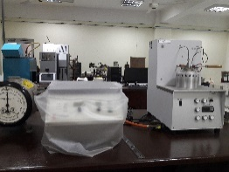
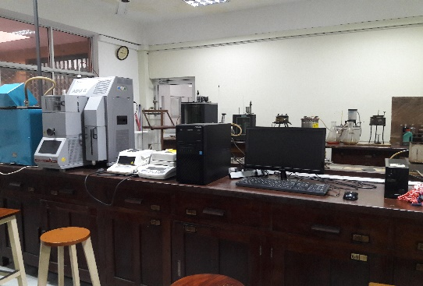
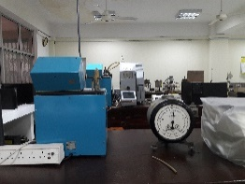
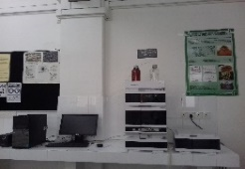
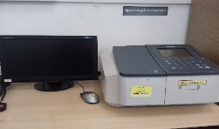
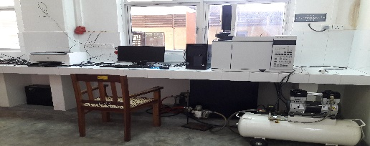
Both undergraduate students and postgraduate students experience the techniques used in qualitative analysis and quantitative analysis related to their subject modules and research projects by using the instruments in the Instrument Centre. For instance, they learn how to identify the unknown components in a mixture and how to determine the relative amounts of the components therein. Further, they can analyze the progress of a reaction.
Petroleum Testing Laboratory
Lecturer in Charge: Dr. Thushara Subasinghe
Technical Officer: Mr. J. Wijesinghe
Lab Attendant: Mr. S. M. R. N. Dhammika
The Petroleum Testing Laboratory is equipped with newest laboratory instruments to facilitate students with experimental work on petroleum engineering. The automated vacuum distillation unit, Sulphur analyzer, Octane analyser, Bomb calorimeter and Viscometer bath are only few experimental setups in the laboratory. As well, it is equipped with necessary apparatus to provide the student with knowledge and experience in Energy Engineering and Fuel Technology. The laboratory includes many apparatuses such as the soxhlet apparatus, Reigdens specific surface apparatus, the Mohr westphal balance, the Pensky Martens closed cup and Cleveland open cup, Engler viscometer and Saybolt universal viscometer, Penetrometer, Universal torsion viscometer, Pilot plant leaching unit etc.

24-hour-Research Laboratory
Lecturer in Charge: Prof. Shantha Amarasinghe
Technical Officer: Mrs. Ishara Gayani
Lab Attendant: Mr. B. Karunathilake
24 hours laboratory is a research laboratory providing facilities for research students to work around the clock. Department of Chemical and Process Engineering offers research programs leading to PhD, MPhil and MSc. Two separate laboratory units are currently available with basic facilities for the research students to set up their test rigs and other equipment required for their experimental work. Computer facilities are also provided with unlimited access. Undergraduate students with research projects involving longer time durations for their experimental work are also encouraged to use 24 hours laboratory.

Proposed 24-hour-Research Laboratory
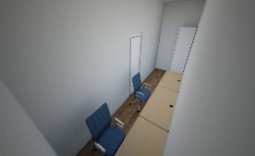

Resources

Prof Hubert D J Silva Memorial Resource Centre
The Department of Chemical and Process Engineering offers the students with access to a valuable collection of literature, specialising in the Chemical and Process Engineering field. The Resource Centre is full of worthy reference material relevant to many branching of Chemical and Process Engineering, facilitating both the undergraduates and postgraduates with their academic and research activities.
Student Common Room
The Student Common Room is established to provide the undergraduates with an opportunity to socialize themselves.
Wi-Fi Access Facility
The students are provided with Wi-Fi facilities to acquire necessary knowledge and reference materials that are required for their academic studies and activities.
Study Zones
Spaces have been provided for the students with seating arrangements and Wi-Fi facilities to engage in academic activities and studies such as group activities and discussions.

Operational Hours and Access to Laboratory Facilities and Resources

Department of Chemical and Process Engineering is usually open for academic work from 8.00 a.m. to 4.15 p.m.
All laboratory Facilities in Department of Chemical Engineering are available for students strictly during the scheduled practical sessions, and students should not use and interfere with any equipment without the permission of the Lecturer in Charge or under the guidance of a Laboratory Instructor.
The CAPD/ CAM Centre is open from 8.00 a.m. to 8.00 p.m. on weekdays and from 8.00 a.m. to 4.00 p.m. on Saturdays.
At present all other facilities are available during working hours only.

OTHER INFORMATION

Getting Help and Advice
A professional full-time counsellor is employed by the University to provide professional counselling to the students who require special attention.
Career guidance unit of the UOM plays an important role in developing University Industry links and provide necessary guidance for the students to select their future career.
In order to address common student problems, the faculty of engineering has further appointed a Staff-Student Liaison Committee at faculty level which has representatives comprising senior academic staff members of the faculty and nominees from respective student groups. The department Staff-student liaison committee helps to solve issues related to academic work, facilities etc.
The office of the Director of Undergraduate Studies provides guidelines, performance criteria and registration procedures to students. The student performance records are also available at this office for their perusal, giving the opportunity for the students to plan the academic activities accordingly.
The DCPE staff was reported as one of the friendliest in the faculty (SWOT analysis report, IRQUE reviewers report). This encourages the students to approach the staff members about their problems to discuss at personal level.
The DCPE has appointed level coordinators for each level to guide the students on subject selection and other academic issues related to each level. The Department has also appointed Advisors for each student to provide guidance and necessary counseling on academic and personal problems during their stay at the University.
The students are given a course outline at the beginning of each semester for each subject. This gives the course objective, learning outcomes, subject coordinator, lecturers, module content, evaluation criteria and a list of references
The students are strongly encouraged to discuss the subject matter with respective subject coordinator or the lecturers.

IESL Membership
The Institute of Engineers’ is the premier engineering body of Sri Lanka. Members benefit by the development of individual’s professional career and building network of technical and social contacts.
We encourage all CPE students to apply for the student membership category. For further information contact the Industrial Training Division, University of Moratuwa.

American Institute of Chemical Engineers (AIChE) Student Chapter
The AIChE Student Chapter of University of Moratuwa is an association formed by students of department of chemical and process engineering at University of Moratuwa in collaboration with ‘The American Institute of Chemical Engineers’, (AIChE) which is a professional association of more than 50,000 members that provides leadership in advancing the chemical engineering profession.
The AIChE Student Chapter of University of Moratuwa is dedicated to providing its members with experiences to take a step beyond class and expand the skills and knowledge obtained during their University years.
As a professional community consists of students, AIChE Student Chapter of University of Moratuwa arranges opportunities for students to build a network of contacts in academia and in industry, fosters and disseminates chemical and process engineering knowledge and concepts used in the industry, supports the professional and personal growth of its members, and applies the expertise of its members to address societal needs.

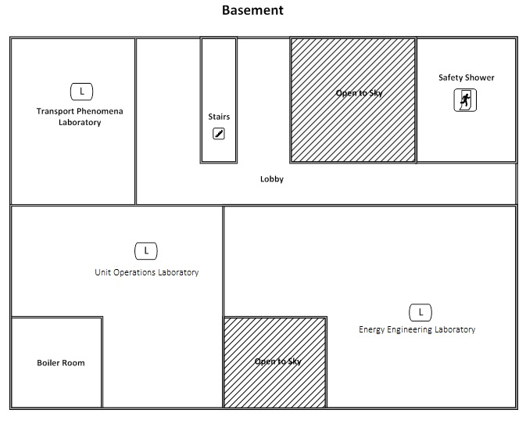
FLOOR PLAN OF DCPE
FLOOR PLAN OF DCPE

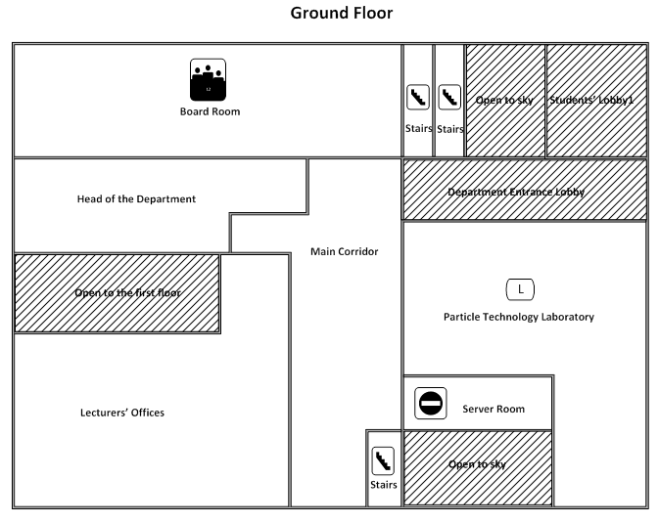

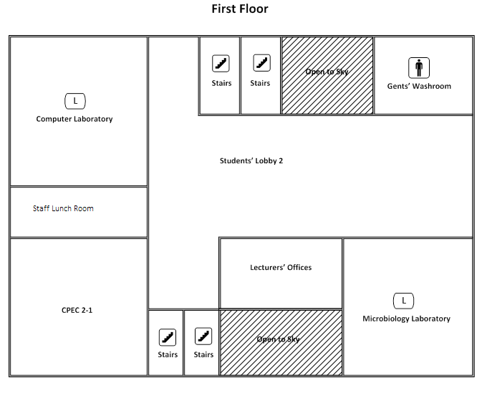

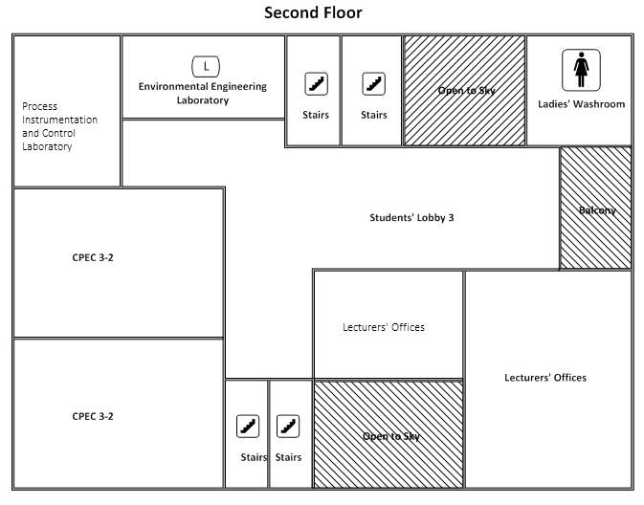

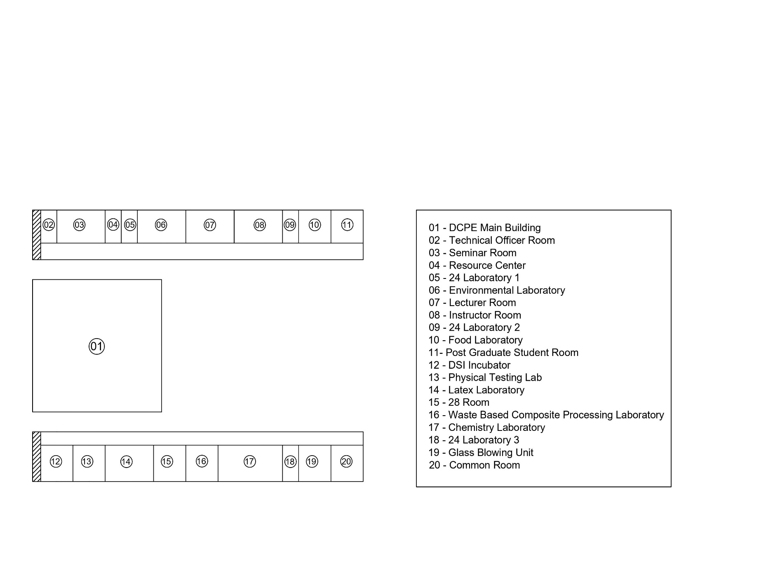
Entrance
Garden

