Title of the Paper (Times New Roman, 13, Bold)
(1st Authors Name)¹ and (2nd Authors name)² (Times New Roman, 12)
Abstract (Times New Roman, 12 Bold)
Maximum 2 pages
Body text (Times New Roman, 12) minimum 300 to maximum 500 words
1.5 Line spacing
Justify
Margin – Left 1.25” / Right 1”/ Top 1”/ Bottom 1”
Keywords: keyword A, keyword B, keyword C, keyword D, keyword E, keyword F
Foot Note – Page 1 (Times New Roman, 12)
_________________________
- (1st Authors title, affiliation, address, e-mail)
- (2nd Authors title, affiliation, address, e-mail)
Headings and Sub-headings

Section Headings (Times New Roman, 12 Bold)

Sub-Headings (Times New Roman, 12)
Table Caption
Table 1: Relationship of Speed and Density (Times New Roman, 11, Center)

Figure Caption
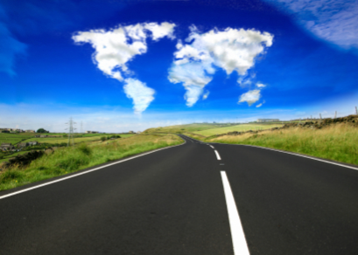
Figure 1: Road Network
Equation
Equations should be made by Equation Editor.
$$A=πr^{2}$$
Reference
APA 6th Edition

