Paper Number:
(For office use only)

TITLE OF THE RESEARCH PAPER (Cambria, 14pt, Bold, Upper Case, Center-Aligned)

ABSTRACT (Cambria, 11pt, Bold, Upper Case, Left-Aligned)

The abstract should state the problem and the objective of the study, the research approach followed, and a summary of the results and conclusions. It should be understandable to the general reader and contain a minimum of acronyms and jargon. The abstract should contain no more than 300 words. Write concisely and clearly. Font style – Cambria, 11pt, Italic, Text justified.

Keywords: Research, Self-discipline, Sixth edition, Template, Writing.
(Cambria, 11pt, Bold only the title, maximum of 5 keywords arranged in alphabetical order leaving two-line spaces between the abstract and keywords, each keyword should start with an upper-case letter, separated by commas, followed by a single space, and a full stop at the end.)

- Introduction (Cambria, 11pt, Bold with Initial Letters Capitalized, Left-Aligned)

A full paper presents completed work and it should contain an introduction to the study with objectives, literature review, methodology, results and discussion, conclusion, acknowledgement, and references presented in detail with separate headings. The full paper must be written in clear, grammatically accurate English.

The full paper including text, tables, figures, and references should be between 8 to 12 pages in length with page numbering at the bottom center of the page.

Please DO NOT change the paper formatting: Paper size – A4, Margins – Left 1.5 inches and all others 1 inch, Line spacing – 1.15, single column, Font style – Cambria, 11pt, Text justified, Page number – Bottom centered.

The heading of a section and a subsection should be in Cambria, 11pt, bold with initial letters capitalized. For subsections, a word like the or of is not capitalized unless it is the first word of the heading.

The introduction section should
- present the scope and objective of the paper and state the problem,
- summarize the significant literature,
- briefly describe the methods, and
- provide an overview of the main results of the work.

  - Subsection (Cambria, 11pt, Bold with Initial Letters Capitalized, Left-Aligned)

Authors are requested to carefully revise the paper for English language and formatting. Please note that the submitted paper will undergo a plagiarism check using Turnitin.

- Literature Review

Provide a summarized and updated review of the literature about the area of study.

- Methodology

The methodology must be clearly stated and described sufficiently in detail or with references.

- Results/Analysis and Discussion

The authors should present the results of the study and the discussion should focus on how the research was instrumental in achieving the objectives.

The findings and arguments of the work should be explicitly described and illustrated. Supporting tables, figures, and images of the results may also be included.

All the tables, figures, and images should be centered. Tables, figures, and images should be numbered (see Figure 1 or Table 2 for an example). A figure or an image caption should be placed under the figure or image and a table caption should be placed at the top.

The word “Table”, “Figure”, or “Image” and the associated number in the caption should be in Cambria, 10pt, bold. Then, present the caption in plain text in Cambria, 10pt with only the initial letter and any proper names capitalized and a full stop at the end.

Cite the table, figure, or image if it–or its data–came from a source, using APA style. The word “Source” should be in plain text Cambria, 10pt and a full stop at the end.

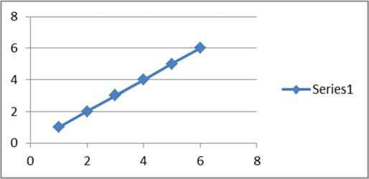

Figure 1. A nice linear plot.

Table 2: A nice table.

Label | Label | Label
Source: APA style.

- Conclusion and Implications

Conclusion should include
- the principles and generalizations inferred from the results,
- any exceptions or problems with those principles and generalizations,
- theoretical and/or practical implications of the study, and
- conclusions drawn and future recommendations.

Acknowledgement

Any acknowledgement that authors wish to make for the support received for the research study.

References

The references should only include published material accessible to the public. Proprietary information such as internal reports may not be cited.
The references should follow APA (latest edition) style and carefully check for completeness, accuracy, and consistency. The style guideline can be found at
https://uom.lk/sites/default/files/lib/files/APA_7th_User_Guide_2021-Web_2_0.pdf.

