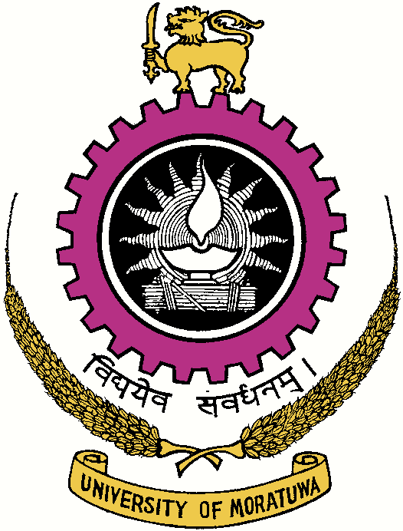

UNIVERSITY OF MORATUWA

SRI LANKA

VACANCIES

University of Moratuwa will entertain applications for the under mentioned posts from suitably qualified persons.

- Audio Visual Technical Officer (Grade II)
Qualifications:
(a) Diploma in Technology of the Open University or Special Engineering Apprenticeship Certificate issued from 1975 or National Diploma for Engineering technicians issued from 1989 by the National Apprenticeship Board or National Diploma in Technology or City and Guilds Final Certificate in the field of Electronics or Power, together with one year’s experience in relevant video work.
OR

(b) Diploma in Educational Technology or Diploma in Audio Visual Techniques of a recognized polytechnic or University Provided the courses for the Diploma in Educational Technology or the Diploma in Audio Visual Techniques are of two years duration, with 01 year experience in relevant video work.
OR
(c) Pass in 03 subjects at the G.C.E. (A/L) examination in Science in one sitting and 06 year experience in Audio Visual work.
Age: Not more than 45 years
Salary Scale: Rs. 42,590 - 20x615; 1x615 – 55,505p.m. [U-MN 4 (II)]
(Salary Scale for 2020 as per Commission Circular No. 17/2016 (v) as at
01.01.2020)
** In addition to the salary, the cost of living allowance and other approved allowances will be paid to the selected candidate/s.

- Blacksmith (Grade II)
Qualifications:
- Ability to read and write

- Should be conversant with-

- Different types of joints used in the process of fire welding.

- The various heat treatment processes of ferrous metals and their tests;
- The method of forging spring steel and their tempering;

- The care and the use of the tools in the Blacksmith Trade.

- Not less than 2 years experience in a Smithy Shop.

- Age- Not more than 45 years.

Salary Scale: Rs. 24, 209 – 16x218–27,697p.m. [U-PL 3(III)]
(Salary Scale for 2018 as per Commission Circular No. 17/2016)

** In addition to the salary, the cost of living allowance and other approved allowances will be paid to the selected candidate/s.

03. Electronic Repairman (Grade II)
Qualifications:
(i) Ability to read and write.

(ii) Should have the ability to –

- Read and understand simple circuit diagrams and wiring diagrams ;

- Use test equipment commonly used in electronic repair work such as signal generators, multimeters and cathode ray escilloscopes;

- Lay out neatly, selder and construct electronic circuits from given circuit diagrams.

(iii) Not less than 2 years experience in associate work.

NOTE : Preference will be given to those having passed the 7th standard.

Age : Not more than 45 years.
Salary Scale : Rs. 24, 209 – 16x218–27,697p.m. [U-PL 3(III)]
(Salary Scale for 2018 as per Commission Circular No. 17/2016)

** In addition to the Basic salary, the Cost of living allowance and other
Approved allowances will be paid to the selected candidate/s.

Duly completed applications should be forwarded under registered cover indicating the Post applied for on the top left hand corner of the envelope to reach the Assistant Registrar, Establishments (Non academic) Division, University of Moratuwa, Moratuwa on or before 08.01.2019.
Further particulars and application forms could be obtained from the Office of the Assistant Registrar, Establishments (Non academic) of this University by personally calling over or by post by sending a self addressed stamped envelope 25.5 cm x 10 cm in size to reach the Assistant Registrar, Establishments (Non academic) of this University or could be downloaded from the University web site - www.mrt.ac.lk.

Applicants from the Higher Education Institutions/Government Departments/Corporations and Statutory Boards should be channeled through the Heads of respective Institutions.

The Applications received after the closing date and not mentioning required information, unclear document/s or failure to fulfill the requirements will cause the rejection of application without intimation.

The candidate/s are recruited based on the written/ Practical /Trade tests and Interview marks.

Acting Registrar

University of Moratuwa
Moratuwa.
12th December, 2018

