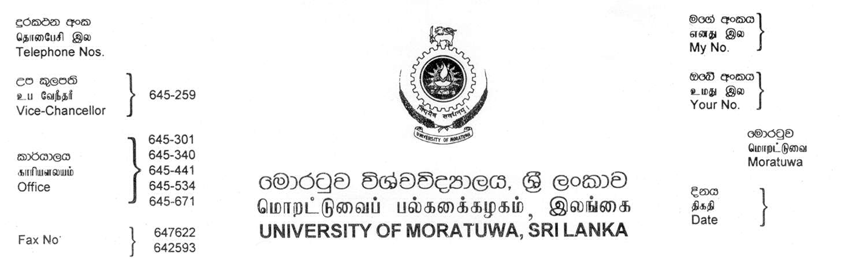
2650301
2650534
2650441
2650340
2651259

2651587

2651186
MO/SU/EE-01/01/2020

24.02.2020

Dear Sir

PURCHASE OF HIGH PERFORMACE WORKSTATION.

Quotations are invited for the purchase of High Performance Workstation the Dept of Electrical Engineering, University of Moratuwa.

Please be good enough to forward your quotation for the supply of same giving the following particulars.

- Price should be of C.I.F.
- H S Code
- Weight and Measurement of the package
- Country of Origin
- Your offer should be valid for minimum period of 4 months.
- Time required dispatching the goods when order is confirmed.
- Proprietary certificate / Manufacturer authorization Certificate

If your offer is acceptable to the University a letter will confirm the purchase and payment will be done by a Irrevocable letter of credit or wire transfer through our Bankers. Please send your quotation to Senior Assistant Bursar (Supplies Division), University of Moratuwa, Katubedda, Moratuwa, Sri Lanka to reach on or before 10.03.2020 (Supplies@uom.lk)

Thank you,
Yours faithfully,

Senior Assistant Bursar/Supplies

